1 run......

training 1 epoch...

5.604862213134766 seconds used......

1 training finished! average train loss: 1.0801847328742344

evaluating...

Confusion matrix, without normalization

[[ 0 34 7]

[ 0 32 63]

[ 0 299 415]]

Normalized confusion matrix

[[0. 0.82926829 0.17073171]

[0. 0.33684211 0.66315789]

[0. 0.41876751 0.58123249]]

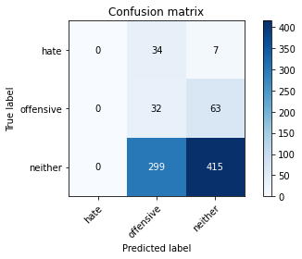

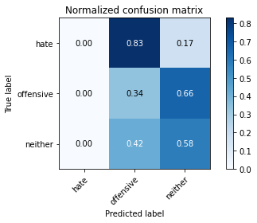

/opt/conda/lib/python3.7/site-packages/sklearn/metrics/_classification.py:1245: UndefinedMetricWarning: Precision and F-score are ill-defined and being set to 0.0 in labels with no predicted samples. Use `zero_division` parameter to control this behavior.

_warn_prf(average, modifier, msg_start, len(result))

/opt/conda/lib/python3.7/site-packages/sklearn/metrics/_classification.py:1245: UndefinedMetricWarning: Precision and F-score are ill-defined and being set to 0.0 in labels with no predicted samples. Use `zero_division` parameter to control this behavior.

_warn_prf(average, modifier, msg_start, len(result))

/opt/conda/lib/python3.7/site-packages/sklearn/metrics/_classification.py:1245: UndefinedMetricWarning: Precision and F-score are ill-defined and being set to 0.0 in labels with no predicted samples. Use `zero_division` parameter to control this behavior.

_warn_prf(average, modifier, msg_start, len(result))

precision recall f1-score support

hate 0.00 0.00 0.00 41

offensive 0.09 0.34 0.14 95

neither 0.86 0.58 0.69 714

accuracy 0.53 850

macro avg 0.31 0.31 0.28 850

weighted avg 0.73 0.53 0.60 850

average eval_loss: 0.8434270644603774, accuracy: 0.5258823529411765

training 2 epoch...

5.580347299575806 seconds used......

2 training finished! average train loss: 0.9374181495772468

evaluating...

Confusion matrix, without normalization

[[ 0 36 5]

[ 0 83 12]

[ 0 318 396]]

Normalized confusion matrix

[[0. 0.87804878 0.12195122]

[0. 0.87368421 0.12631579]

[0. 0.44537815 0.55462185]]

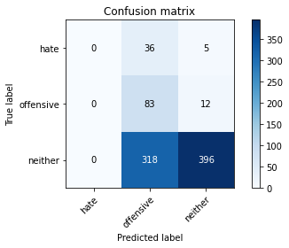

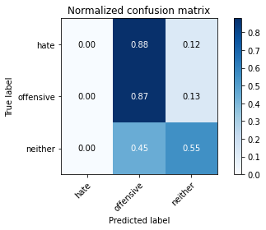

/opt/conda/lib/python3.7/site-packages/sklearn/metrics/_classification.py:1245: UndefinedMetricWarning: Precision and F-score are ill-defined and being set to 0.0 in labels with no predicted samples. Use `zero_division` parameter to control this behavior.

_warn_prf(average, modifier, msg_start, len(result))

/opt/conda/lib/python3.7/site-packages/sklearn/metrics/_classification.py:1245: UndefinedMetricWarning: Precision and F-score are ill-defined and being set to 0.0 in labels with no predicted samples. Use `zero_division` parameter to control this behavior.

_warn_prf(average, modifier, msg_start, len(result))

/opt/conda/lib/python3.7/site-packages/sklearn/metrics/_classification.py:1245: UndefinedMetricWarning: Precision and F-score are ill-defined and being set to 0.0 in labels with no predicted samples. Use `zero_division` parameter to control this behavior.

_warn_prf(average, modifier, msg_start, len(result))

precision recall f1-score support

hate 0.00 0.00 0.00 41

offensive 0.19 0.87 0.31 95

neither 0.96 0.55 0.70 714

accuracy 0.56 850

macro avg 0.38 0.48 0.34 850

weighted avg 0.83 0.56 0.63 850

average eval_loss: 0.8753387997316759, accuracy: 0.5635294117647058

training 3 epoch...

5.56008243560791 seconds used......

3 training finished! average train loss: 0.8191216836373011

evaluating...

Confusion matrix, without normalization

[[ 1 38 2]

[ 2 91 2]

[ 16 475 223]]

Normalized confusion matrix

[[0.02439024 0.92682927 0.04878049]

[0.02105263 0.95789474 0.02105263]

[0.02240896 0.66526611 0.31232493]]

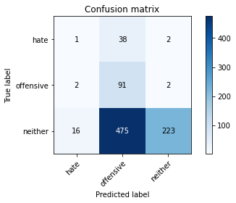

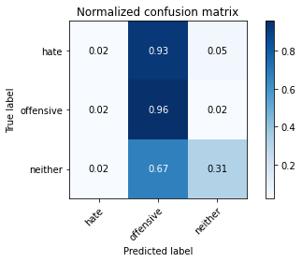

precision recall f1-score support

hate 0.05 0.02 0.03 41

offensive 0.15 0.96 0.26 95

neither 0.98 0.31 0.47 714

accuracy 0.37 850

macro avg 0.40 0.43 0.26 850

weighted avg 0.84 0.37 0.43 850

average eval_loss: 1.2058850533740466, accuracy: 0.37058823529411766

training 4 epoch...

5.632796049118042 seconds used......

4 training finished! average train loss: 0.6797925730546316

evaluating...

Confusion matrix, without normalization

[[ 2 23 16]

[ 2 69 24]

[ 14 160 540]]

Normalized confusion matrix

[[0.04878049 0.56097561 0.3902439 ]

[0.02105263 0.72631579 0.25263158]

[0.01960784 0.22408964 0.75630252]]

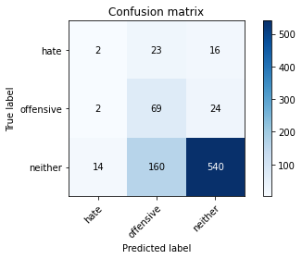

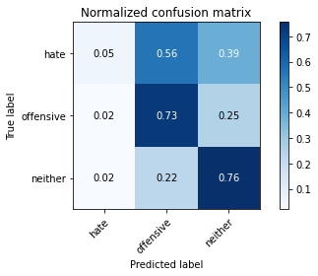

precision recall f1-score support

hate 0.11 0.05 0.07 41

offensive 0.27 0.73 0.40 95

neither 0.93 0.76 0.83 714

accuracy 0.72 850

macro avg 0.44 0.51 0.43 850

weighted avg 0.82 0.72 0.75 850

average eval_loss: 0.6838435232639313, accuracy: 0.7188235294117648

training 5 epoch...

5.58859395980835 seconds used......

5 training finished! average train loss: 0.4579874873161316

evaluating...

Confusion matrix, without normalization

[[ 11 22 8]

[ 6 80 9]

[ 67 227 420]]

Normalized confusion matrix

[[0.26829268 0.53658537 0.19512195]

[0.06315789 0.84210526 0.09473684]

[0.09383754 0.31792717 0.58823529]]

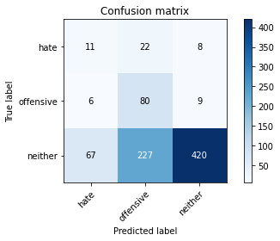

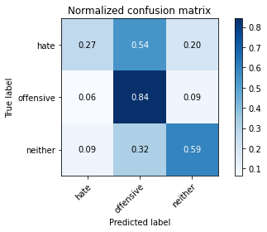

precision recall f1-score support

hate 0.13 0.27 0.18 41

offensive 0.24 0.84 0.38 95

neither 0.96 0.59 0.73 714

accuracy 0.60 850

macro avg 0.45 0.57 0.43 850

weighted avg 0.84 0.60 0.66 850

average eval_loss: 0.9752475783921951, accuracy: 0.6011764705882353

training 6 epoch...

5.6719605922698975 seconds used......

6 training finished! average train loss: 0.28279254999425674

evaluating...

Confusion matrix, without normalization

[[ 18 9 14]

[ 22 45 28]

[106 100 508]]

Normalized confusion matrix

[[0.43902439 0.2195122 0.34146341]

[0.23157895 0.47368421 0.29473684]

[0.14845938 0.14005602 0.71148459]]

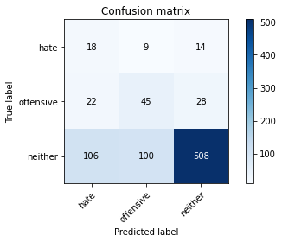

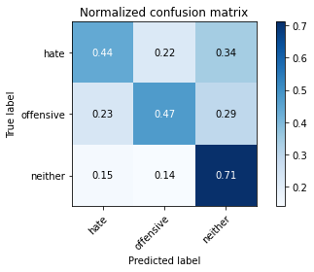

precision recall f1-score support

hate 0.12 0.44 0.19 41

offensive 0.29 0.47 0.36 95

neither 0.92 0.71 0.80 714

accuracy 0.67 850

macro avg 0.45 0.54 0.45 850

weighted avg 0.81 0.67 0.72 850

average eval_loss: 0.7993334428905401, accuracy: 0.6717647058823529

training 7 epoch...

5.602225065231323 seconds used......

7 training finished! average train loss: 0.13184226702691781

evaluating...

Confusion matrix, without normalization

[[ 14 18 9]

[ 17 66 12]

[109 176 429]]

Normalized confusion matrix

[[0.34146341 0.43902439 0.2195122 ]

[0.17894737 0.69473684 0.12631579]

[0.15266106 0.2464986 0.60084034]]

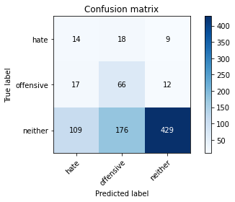

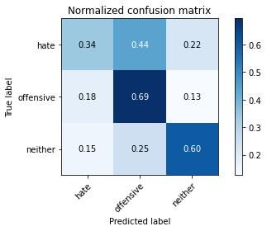

precision recall f1-score support

hate 0.10 0.34 0.15 41

offensive 0.25 0.69 0.37 95

neither 0.95 0.60 0.74 714

accuracy 0.60 850

macro avg 0.44 0.55 0.42 850

weighted avg 0.83 0.60 0.67 850

average eval_loss: 1.2121799784864105, accuracy: 0.5988235294117648

training 8 epoch...

5.648677825927734 seconds used......

8 training finished! average train loss: 0.05903767546017965

evaluating...

Confusion matrix, without normalization

[[ 11 18 12]

[ 9 61 25]

[ 63 144 507]]

Normalized confusion matrix

[[0.26829268 0.43902439 0.29268293]

[0.09473684 0.64210526 0.26315789]

[0.08823529 0.20168067 0.71008403]]

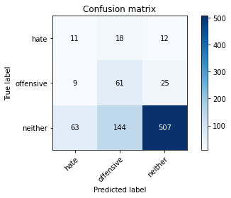

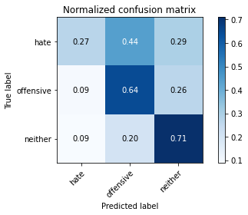

precision recall f1-score support

hate 0.13 0.27 0.18 41

offensive 0.27 0.64 0.38 95

neither 0.93 0.71 0.81 714

accuracy 0.68 850

macro avg 0.45 0.54 0.46 850

weighted avg 0.82 0.68 0.73 850

average eval_loss: 1.021846291614523, accuracy: 0.6811764705882353

training 9 epoch...

5.634117841720581 seconds used......

9 training finished! average train loss: 0.03393449052236974

evaluating...

Confusion matrix, without normalization

[[ 10 19 12]

[ 12 60 23]

[ 68 158 488]]

Normalized confusion matrix

[[0.24390244 0.46341463 0.29268293]

[0.12631579 0.63157895 0.24210526]

[0.0952381 0.22128852 0.68347339]]

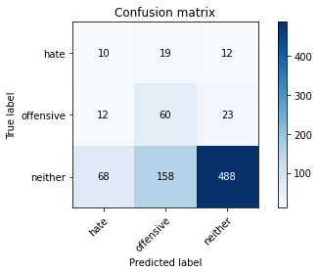

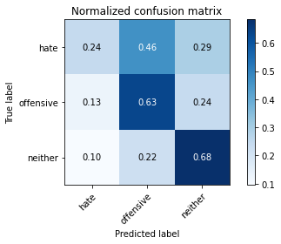

precision recall f1-score support

hate 0.11 0.24 0.15 41

offensive 0.25 0.63 0.36 95

neither 0.93 0.68 0.79 714

accuracy 0.66 850

macro avg 0.43 0.52 0.43 850

weighted avg 0.82 0.66 0.71 850

average eval_loss: 1.1363783080325744, accuracy: 0.6564705882352941

training 10 epoch...

5.59879994392395 seconds used......

10 training finished! average train loss: 0.013448270542236665

evaluating...

Confusion matrix, without normalization

[[ 7 19 15]

[ 2 59 34]

[ 30 156 528]]

Normalized confusion matrix

[[0.17073171 0.46341463 0.36585366]

[0.02105263 0.62105263 0.35789474]

[0.04201681 0.21848739 0.7394958 ]]

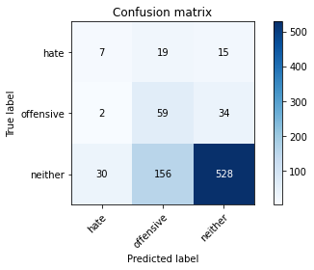

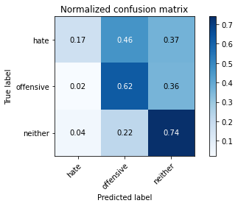

precision recall f1-score support

hate 0.18 0.17 0.18 41

offensive 0.25 0.62 0.36 95

neither 0.92 0.74 0.82 714

accuracy 0.70 850

macro avg 0.45 0.51 0.45 850

weighted avg 0.81 0.70 0.74 850

average eval_loss: 1.077549699317599, accuracy: 0.6988235294117647

training 11 epoch...

5.647073984146118 seconds used......

11 training finished! average train loss: 0.007074616429033793

evaluating...

Confusion matrix, without normalization

[[ 8 19 14]

[ 8 64 23]

[ 55 167 492]]

Normalized confusion matrix

[[0.19512195 0.46341463 0.34146341]

[0.08421053 0.67368421 0.24210526]

[0.07703081 0.23389356 0.68907563]]

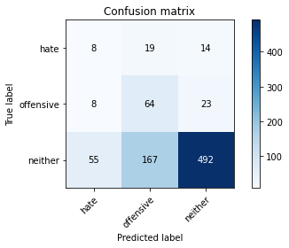

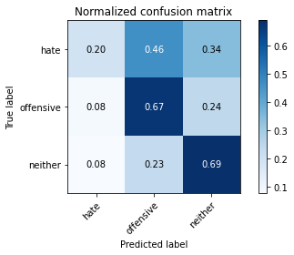

precision recall f1-score support

hate 0.11 0.20 0.14 41

offensive 0.26 0.67 0.37 95

neither 0.93 0.69 0.79 714

accuracy 0.66 850

macro avg 0.43 0.52 0.44 850

weighted avg 0.82 0.66 0.71 850

average eval_loss: 1.2782255532599032, accuracy: 0.6635294117647059

training 12 epoch...

5.604339599609375 seconds used......

12 training finished! average train loss: 0.005746669886219833

evaluating...

Confusion matrix, without normalization

[[ 10 21 10]

[ 11 69 15]

[ 71 181 462]]

Normalized confusion matrix

[[0.24390244 0.51219512 0.24390244]

[0.11578947 0.72631579 0.15789474]

[0.09943978 0.2535014 0.64705882]]

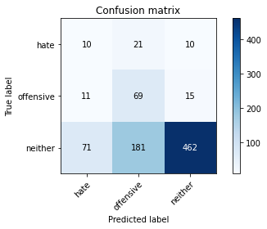

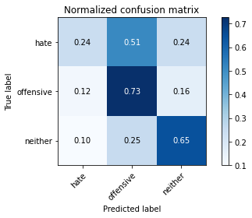

precision recall f1-score support

hate 0.11 0.24 0.15 41

offensive 0.25 0.73 0.38 95

neither 0.95 0.65 0.77 714

accuracy 0.64 850

macro avg 0.44 0.54 0.43 850

weighted avg 0.83 0.64 0.70 850

average eval_loss: 1.5157592658408332, accuracy: 0.6364705882352941

training 13 epoch...

5.570095777511597 seconds used......

13 training finished! average train loss: 0.004257794957892556

evaluating...

Confusion matrix, without normalization

[[ 11 21 9]

[ 11 72 12]

[ 83 209 422]]

Normalized confusion matrix

[[0.26829268 0.51219512 0.2195122 ]

[0.11578947 0.75789474 0.12631579]

[0.1162465 0.29271709 0.59103641]]

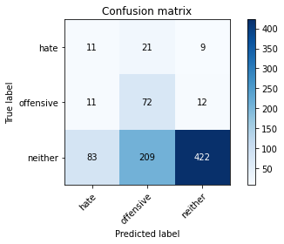

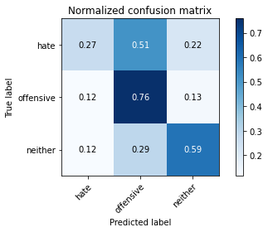

precision recall f1-score support

hate 0.10 0.27 0.15 41

offensive 0.24 0.76 0.36 95

neither 0.95 0.59 0.73 714

accuracy 0.59 850

macro avg 0.43 0.54 0.41 850

weighted avg 0.83 0.59 0.66 850

average eval_loss: 1.8029100193837009, accuracy: 0.5941176470588235

training 14 epoch...

5.603992700576782 seconds used......

14 training finished! average train loss: 0.003574157638164858

evaluating...

Confusion matrix, without normalization

[[ 10 18 13]

[ 8 66 21]

[ 55 160 499]]

Normalized confusion matrix

[[0.24390244 0.43902439 0.31707317]

[0.08421053 0.69473684 0.22105263]

[0.07703081 0.22408964 0.69887955]]

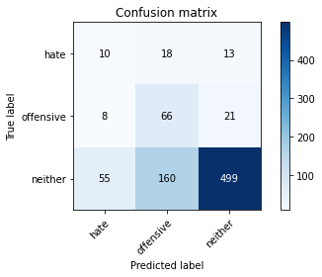

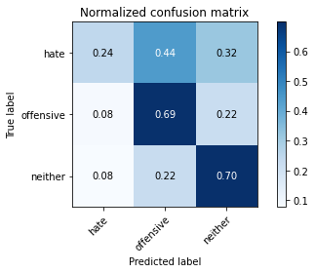

precision recall f1-score support

hate 0.14 0.24 0.18 41

offensive 0.27 0.69 0.39 95

neither 0.94 0.70 0.80 714

accuracy 0.68 850

macro avg 0.45 0.55 0.46 850

weighted avg 0.82 0.68 0.72 850

average eval_loss: 1.382792001901476, accuracy: 0.6764705882352942

training 15 epoch...

5.6245996952056885 seconds used......

15 training finished! average train loss: 0.0024218510920440573

evaluating...

Confusion matrix, without normalization

[[ 9 20 12]

[ 8 66 21]

[ 56 173 485]]

Normalized confusion matrix

[[0.2195122 0.48780488 0.29268293]

[0.08421053 0.69473684 0.22105263]

[0.07843137 0.24229692 0.67927171]]

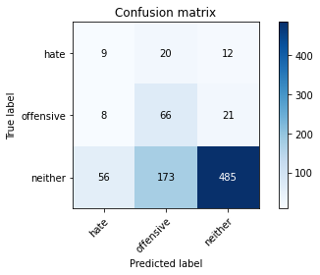

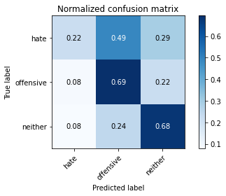

precision recall f1-score support

hate 0.12 0.22 0.16 41

offensive 0.25 0.69 0.37 95

neither 0.94 0.68 0.79 714

accuracy 0.66 850

macro avg 0.44 0.53 0.44 850

weighted avg 0.82 0.66 0.71 850

average eval_loss: 1.4837549737232283, accuracy: 0.6588235294117647

training 16 epoch...

5.571966648101807 seconds used......

16 training finished! average train loss: 0.0020197702300113938

evaluating...

Confusion matrix, without normalization

[[ 9 18 14]

[ 8 63 24]

[ 49 163 502]]

Normalized confusion matrix

[[0.2195122 0.43902439 0.34146341]

[0.08421053 0.66315789 0.25263158]

[0.06862745 0.22829132 0.70308123]]

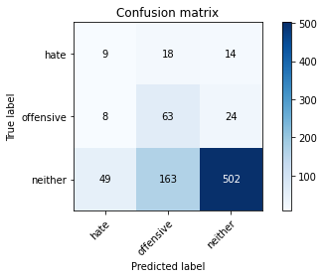

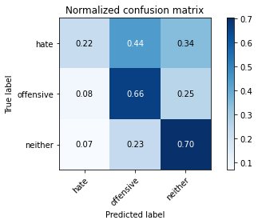

precision recall f1-score support

hate 0.14 0.22 0.17 41

offensive 0.26 0.66 0.37 95

neither 0.93 0.70 0.80 714

accuracy 0.68 850

macro avg 0.44 0.53 0.45 850

weighted avg 0.82 0.68 0.72 850

average eval_loss: 1.4060446961003161, accuracy: 0.6752941176470588

training 17 epoch...

5.6695568561553955 seconds used......

17 training finished! average train loss: 0.0018390293925121012

evaluating...

Confusion matrix, without normalization

[[ 9 18 14]

[ 8 63 24]

[ 55 162 497]]

Normalized confusion matrix

[[0.2195122 0.43902439 0.34146341]

[0.08421053 0.66315789 0.25263158]

[0.07703081 0.22689076 0.69607843]]

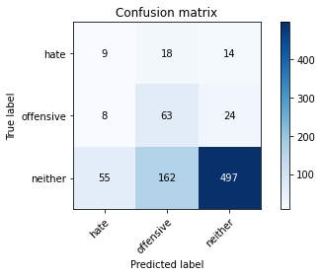

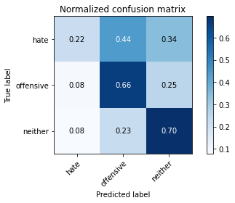

precision recall f1-score support

hate 0.12 0.22 0.16 41

offensive 0.26 0.66 0.37 95

neither 0.93 0.70 0.80 714

accuracy 0.67 850

macro avg 0.44 0.53 0.44 850

weighted avg 0.82 0.67 0.72 850

average eval_loss: 1.458327176303841, accuracy: 0.6694117647058824

training 18 epoch...

5.6145851612091064 seconds used......

18 training finished! average train loss: 0.0015383436418940416

evaluating...

Confusion matrix, without normalization

[[ 10 18 13]

[ 9 62 24]

[ 61 155 498]]

Normalized confusion matrix

[[0.24390244 0.43902439 0.31707317]

[0.09473684 0.65263158 0.25263158]

[0.08543417 0.21708683 0.69747899]]

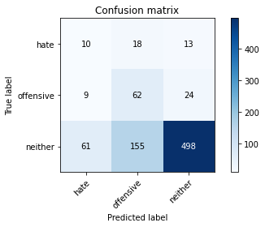

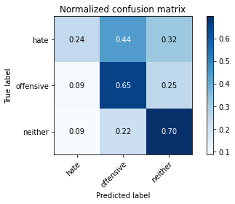

precision recall f1-score support

hate 0.12 0.24 0.17 41

offensive 0.26 0.65 0.38 95

neither 0.93 0.70 0.80 714

accuracy 0.67 850

macro avg 0.44 0.53 0.45 850

weighted avg 0.82 0.67 0.72 850

average eval_loss: 1.4728793553401565, accuracy: 0.6705882352941176

training 19 epoch...

5.72779655456543 seconds used......

19 training finished! average train loss: 0.0014083002865340353

evaluating...

Confusion matrix, without normalization

[[ 9 18 14]

[ 9 59 27]

[ 60 146 508]]

Normalized confusion matrix

[[0.2195122 0.43902439 0.34146341]

[0.09473684 0.62105263 0.28421053]

[0.08403361 0.20448179 0.71148459]]

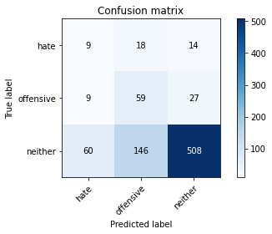

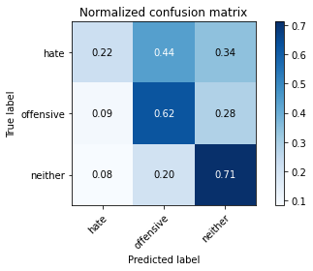

precision recall f1-score support

hate 0.12 0.22 0.15 41

offensive 0.26 0.62 0.37 95

neither 0.93 0.71 0.80 714

accuracy 0.68 850

macro avg 0.44 0.52 0.44 850

weighted avg 0.81 0.68 0.72 850

average eval_loss: 1.4494435815952804, accuracy: 0.6776470588235294

training 20 epoch...

5.612541913986206 seconds used......

20 training finished! average train loss: 0.0012625028919299236

evaluating...

Confusion matrix, without normalization

[[ 10 19 12]

[ 8 64 23]

[ 56 160 498]]

Normalized confusion matrix

[[0.24390244 0.46341463 0.29268293]

[0.08421053 0.67368421 0.24210526]

[0.07843137 0.22408964 0.69747899]]

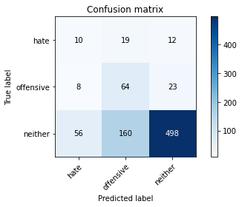

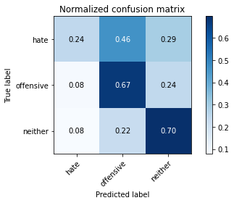

precision recall f1-score support

hate 0.14 0.24 0.17 41

offensive 0.26 0.67 0.38 95

neither 0.93 0.70 0.80 714

accuracy 0.67 850

macro avg 0.44 0.54 0.45 850

weighted avg 0.82 0.67 0.72 850

average eval_loss: 1.5124696355778724, accuracy: 0.6729411764705883

2 run......

training 1 epoch...

5.671498775482178 seconds used......

1 training finished! average train loss: 1.0561943733029895

evaluating...

Confusion matrix, without normalization

[[ 0 36 5]

[ 0 22 73]

[ 0 276 438]]

Normalized confusion matrix

[[0. 0.87804878 0.12195122]

[0. 0.23157895 0.76842105]

[0. 0.38655462 0.61344538]]

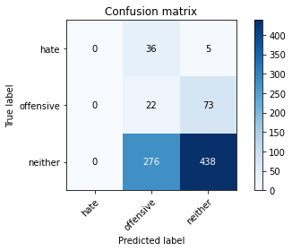

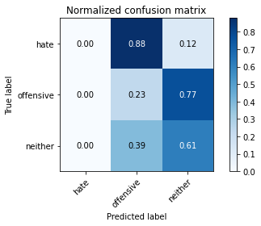

/opt/conda/lib/python3.7/site-packages/sklearn/metrics/_classification.py:1245: UndefinedMetricWarning: Precision and F-score are ill-defined and being set to 0.0 in labels with no predicted samples. Use `zero_division` parameter to control this behavior.

_warn_prf(average, modifier, msg_start, len(result))

/opt/conda/lib/python3.7/site-packages/sklearn/metrics/_classification.py:1245: UndefinedMetricWarning: Precision and F-score are ill-defined and being set to 0.0 in labels with no predicted samples. Use `zero_division` parameter to control this behavior.

_warn_prf(average, modifier, msg_start, len(result))

/opt/conda/lib/python3.7/site-packages/sklearn/metrics/_classification.py:1245: UndefinedMetricWarning: Precision and F-score are ill-defined and being set to 0.0 in labels with no predicted samples. Use `zero_division` parameter to control this behavior.

_warn_prf(average, modifier, msg_start, len(result))

precision recall f1-score support

hate 0.00 0.00 0.00 41

offensive 0.07 0.23 0.10 95

neither 0.85 0.61 0.71 714

accuracy 0.54 850

macro avg 0.30 0.28 0.27 850

weighted avg 0.72 0.54 0.61 850

average eval_loss: 0.8556124748185624, accuracy: 0.5411764705882353

training 2 epoch...

5.639354467391968 seconds used......

2 training finished! average train loss: 0.9328566259808011

evaluating...

Confusion matrix, without normalization

[[ 3 35 3]

[ 2 85 8]

[ 33 372 309]]

Normalized confusion matrix

[[0.07317073 0.85365854 0.07317073]

[0.02105263 0.89473684 0.08421053]

[0.04621849 0.5210084 0.43277311]]

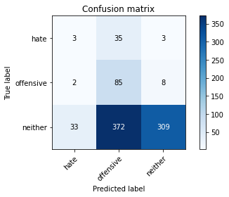

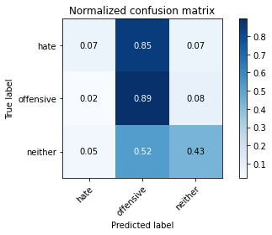

precision recall f1-score support

hate 0.08 0.07 0.08 41

offensive 0.17 0.89 0.29 95

neither 0.97 0.43 0.60 714

accuracy 0.47 850

macro avg 0.41 0.47 0.32 850

weighted avg 0.83 0.47 0.54 850

average eval_loss: 0.957603900238525, accuracy: 0.46705882352941175

training 3 epoch...

5.546095132827759 seconds used......

3 training finished! average train loss: 0.7704115476873186

evaluating...

Confusion matrix, without normalization

[[ 13 20 8]

[ 10 71 14]

[ 75 199 440]]

Normalized confusion matrix

[[0.31707317 0.48780488 0.19512195]

[0.10526316 0.74736842 0.14736842]

[0.10504202 0.27871148 0.6162465 ]]

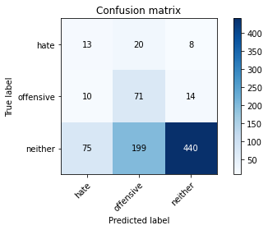

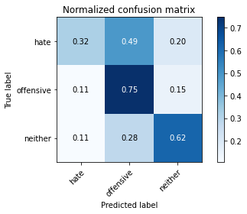

precision recall f1-score support

hate 0.13 0.32 0.19 41

offensive 0.24 0.75 0.37 95

neither 0.95 0.62 0.75 714

accuracy 0.62 850

macro avg 0.44 0.56 0.43 850

weighted avg 0.83 0.62 0.68 850

average eval_loss: 0.8137679827767749, accuracy: 0.6164705882352941

training 4 epoch...

5.54317045211792 seconds used......

4 training finished! average train loss: 0.5812056014935175

evaluating...

Confusion matrix, without normalization

[[ 27 3 11]

[ 28 33 34]

[132 74 508]]

Normalized confusion matrix

[[0.65853659 0.07317073 0.26829268]

[0.29473684 0.34736842 0.35789474]

[0.18487395 0.10364146 0.71148459]]

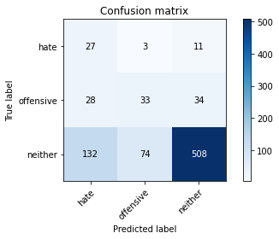

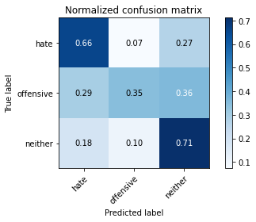

precision recall f1-score support

hate 0.14 0.66 0.24 41

offensive 0.30 0.35 0.32 95

neither 0.92 0.71 0.80 714

accuracy 0.67 850

macro avg 0.45 0.57 0.45 850

weighted avg 0.81 0.67 0.72 850

average eval_loss: 0.7427830477786619, accuracy: 0.668235294117647

training 5 epoch...

5.563213109970093 seconds used......

5 training finished! average train loss: 0.38778700886501205

evaluating...

Confusion matrix, without normalization

[[ 9 22 10]

[ 10 72 13]

[ 54 237 423]]

Normalized confusion matrix

[[0.2195122 0.53658537 0.24390244]

[0.10526316 0.75789474 0.13684211]

[0.07563025 0.33193277 0.59243697]]

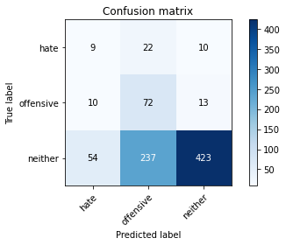

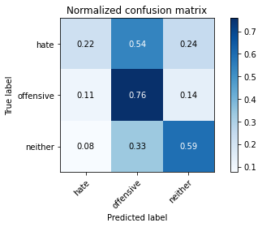

precision recall f1-score support

hate 0.12 0.22 0.16 41

offensive 0.22 0.76 0.34 95

neither 0.95 0.59 0.73 714

accuracy 0.59 850

macro avg 0.43 0.52 0.41 850

weighted avg 0.83 0.59 0.66 850

average eval_loss: 0.9002811004256093, accuracy: 0.5929411764705882

training 6 epoch...

5.617055654525757 seconds used......

6 training finished! average train loss: 0.19426561002102163

evaluating...

Confusion matrix, without normalization

[[ 9 15 17]

[ 8 64 23]

[ 64 140 510]]

Normalized confusion matrix

[[0.2195122 0.36585366 0.41463415]

[0.08421053 0.67368421 0.24210526]

[0.08963585 0.19607843 0.71428571]]

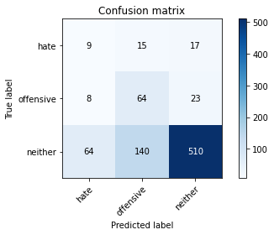

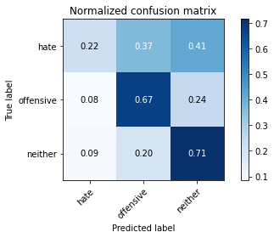

precision recall f1-score support

hate 0.11 0.22 0.15 41

offensive 0.29 0.67 0.41 95

neither 0.93 0.71 0.81 714

accuracy 0.69 850

macro avg 0.44 0.54 0.45 850

weighted avg 0.82 0.69 0.73 850

average eval_loss: 0.7583010934813078, accuracy: 0.6858823529411765

training 7 epoch...

5.612756729125977 seconds used......

7 training finished! average train loss: 0.07029274613079098

evaluating...

Confusion matrix, without normalization

[[ 16 17 8]

[ 15 69 11]

[ 95 205 414]]

Normalized confusion matrix

[[0.3902439 0.41463415 0.19512195]

[0.15789474 0.72631579 0.11578947]

[0.13305322 0.28711485 0.57983193]]

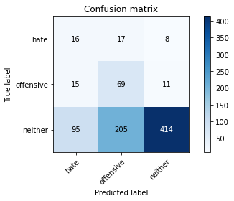

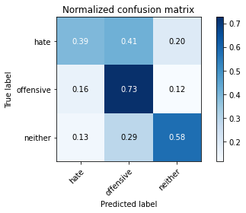

precision recall f1-score support

hate 0.13 0.39 0.19 41

offensive 0.24 0.73 0.36 95

neither 0.96 0.58 0.72 714

accuracy 0.59 850

macro avg 0.44 0.57 0.42 850

weighted avg 0.84 0.59 0.66 850

average eval_loss: 1.2312068236601907, accuracy: 0.5870588235294117

training 8 epoch...

5.607690095901489 seconds used......

8 training finished! average train loss: 0.024520007143211033

evaluating...

Confusion matrix, without normalization

[[ 11 18 12]

[ 9 61 25]

[ 59 172 483]]

Normalized confusion matrix

[[0.26829268 0.43902439 0.29268293]

[0.09473684 0.64210526 0.26315789]

[0.08263305 0.24089636 0.67647059]]

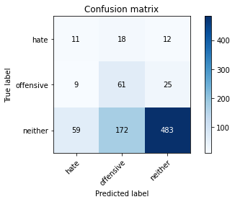

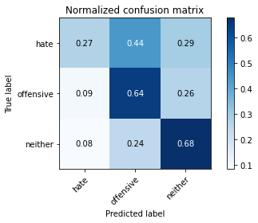

precision recall f1-score support

hate 0.14 0.27 0.18 41

offensive 0.24 0.64 0.35 95

neither 0.93 0.68 0.78 714

accuracy 0.65 850

macro avg 0.44 0.53 0.44 850

weighted avg 0.81 0.65 0.71 850

average eval_loss: 1.0345001427326785, accuracy: 0.6529411764705882

training 9 epoch...

5.643518447875977 seconds used......

9 training finished! average train loss: 0.011047856668786457

evaluating...

Confusion matrix, without normalization

[[ 11 19 11]

[ 8 71 16]

[ 56 195 463]]

Normalized confusion matrix

[[0.26829268 0.46341463 0.26829268]

[0.08421053 0.74736842 0.16842105]

[0.07843137 0.27310924 0.64845938]]

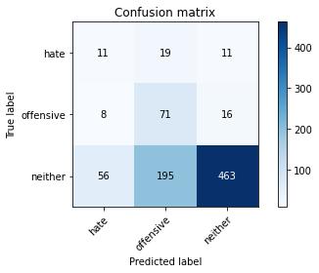

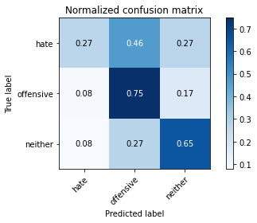

precision recall f1-score support

hate 0.15 0.27 0.19 41

offensive 0.25 0.75 0.37 95

neither 0.94 0.65 0.77 714

accuracy 0.64 850

macro avg 0.45 0.55 0.44 850

weighted avg 0.83 0.64 0.70 850

average eval_loss: 1.217985537130559, accuracy: 0.6411764705882353

training 10 epoch...

5.5831804275512695 seconds used......

10 training finished! average train loss: 0.007141383461809407

evaluating...

Confusion matrix, without normalization

[[ 13 16 12]

[ 8 65 22]

[ 58 172 484]]

Normalized confusion matrix

[[0.31707317 0.3902439 0.29268293]

[0.08421053 0.68421053 0.23157895]

[0.08123249 0.24089636 0.67787115]]

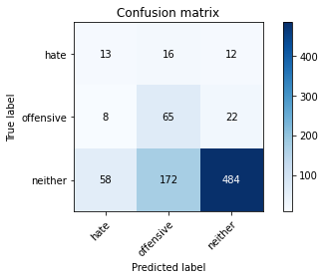

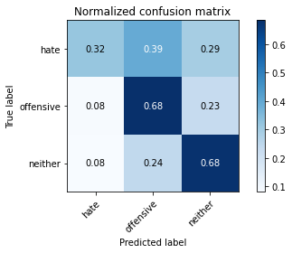

precision recall f1-score support

hate 0.16 0.32 0.22 41

offensive 0.26 0.68 0.37 95

neither 0.93 0.68 0.79 714

accuracy 0.66 850

macro avg 0.45 0.56 0.46 850

weighted avg 0.82 0.66 0.71 850

average eval_loss: 1.1945174892248889, accuracy: 0.6611764705882353

training 11 epoch...

5.572763442993164 seconds used......

11 training finished! average train loss: 0.004861076068158986

evaluating...

Confusion matrix, without normalization

[[ 12 18 11]

[ 8 67 20]

[ 57 176 481]]

Normalized confusion matrix

[[0.29268293 0.43902439 0.26829268]

[0.08421053 0.70526316 0.21052632]

[0.07983193 0.2464986 0.67366947]]

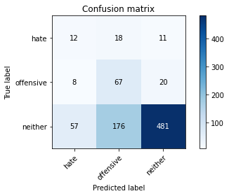

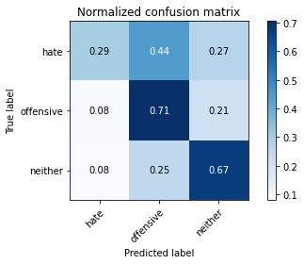

precision recall f1-score support

hate 0.16 0.29 0.20 41

offensive 0.26 0.71 0.38 95

neither 0.94 0.67 0.78 714

accuracy 0.66 850

macro avg 0.45 0.56 0.45 850

weighted avg 0.83 0.66 0.71 850

average eval_loss: 1.2740799825432776, accuracy: 0.6588235294117647

training 12 epoch...

5.598737716674805 seconds used......

12 training finished! average train loss: 0.0036446626763790846

evaluating...

Confusion matrix, without normalization

[[ 10 16 15]

[ 7 63 25]

[ 56 172 486]]

Normalized confusion matrix

[[0.24390244 0.3902439 0.36585366]

[0.07368421 0.66315789 0.26315789]

[0.07843137 0.24089636 0.68067227]]

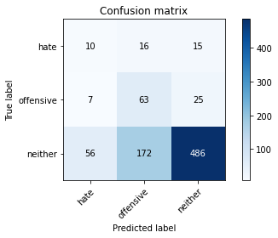

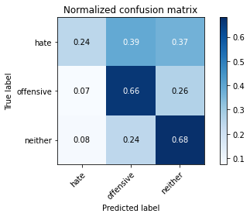

precision recall f1-score support

hate 0.14 0.24 0.18 41

offensive 0.25 0.66 0.36 95

neither 0.92 0.68 0.78 714

accuracy 0.66 850

macro avg 0.44 0.53 0.44 850

weighted avg 0.81 0.66 0.71 850

average eval_loss: 1.2641371884004236, accuracy: 0.6576470588235294

training 13 epoch...

5.597747564315796 seconds used......

13 training finished! average train loss: 0.0032681268284149054

evaluating...

Confusion matrix, without normalization

[[ 11 17 13]

[ 7 64 24]

[ 53 174 487]]

Normalized confusion matrix

[[0.26829268 0.41463415 0.31707317]

[0.07368421 0.67368421 0.25263158]

[0.07422969 0.24369748 0.68207283]]

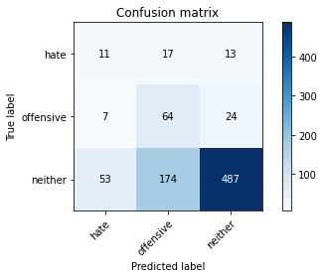

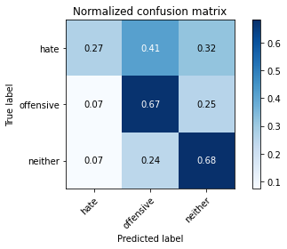

precision recall f1-score support

hate 0.15 0.27 0.20 41

offensive 0.25 0.67 0.37 95

neither 0.93 0.68 0.79 714

accuracy 0.66 850

macro avg 0.45 0.54 0.45 850

weighted avg 0.82 0.66 0.71 850

average eval_loss: 1.3111670925336087, accuracy: 0.6611764705882353

training 14 epoch...

5.588701486587524 seconds used......

14 training finished! average train loss: 0.0023631912869556495

evaluating...

Confusion matrix, without normalization

[[ 12 17 12]

[ 11 63 21]

[ 67 167 480]]

Normalized confusion matrix

[[0.29268293 0.41463415 0.29268293]

[0.11578947 0.66315789 0.22105263]

[0.09383754 0.23389356 0.67226891]]

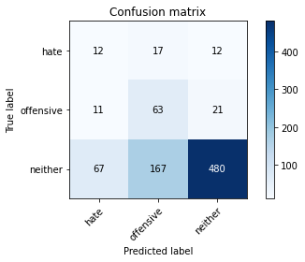

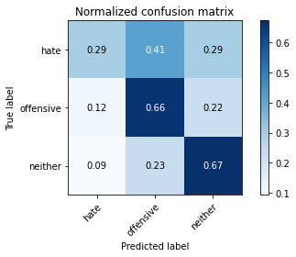

precision recall f1-score support

hate 0.13 0.29 0.18 41

offensive 0.26 0.66 0.37 95

neither 0.94 0.67 0.78 714

accuracy 0.65 850

macro avg 0.44 0.54 0.44 850

weighted avg 0.82 0.65 0.71 850

average eval_loss: 1.3769329915115567, accuracy: 0.6529411764705882

training 15 epoch...

5.548536777496338 seconds used......

15 training finished! average train loss: 0.0020503134955005306

evaluating...

Confusion matrix, without normalization

[[ 12 15 14]

[ 11 51 33]

[ 66 154 494]]

Normalized confusion matrix

[[0.29268293 0.36585366 0.34146341]

[0.11578947 0.53684211 0.34736842]

[0.09243697 0.21568627 0.69187675]]

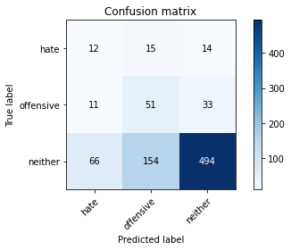

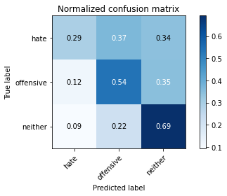

precision recall f1-score support

hate 0.13 0.29 0.18 41

offensive 0.23 0.54 0.32 95

neither 0.91 0.69 0.79 714

accuracy 0.66 850

macro avg 0.43 0.51 0.43 850

weighted avg 0.80 0.66 0.71 850

average eval_loss: 1.321165271655678, accuracy: 0.6552941176470588

training 16 epoch...

5.61427116394043 seconds used......

16 training finished! average train loss: 0.0018243246514531267

evaluating...

Confusion matrix, without normalization

[[ 10 19 12]

[ 7 67 21]

[ 45 199 470]]

Normalized confusion matrix

[[0.24390244 0.46341463 0.29268293]

[0.07368421 0.70526316 0.22105263]

[0.06302521 0.27871148 0.65826331]]

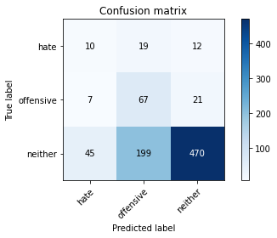

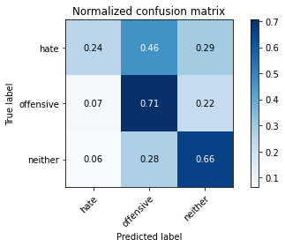

precision recall f1-score support

hate 0.16 0.24 0.19 41

offensive 0.24 0.71 0.35 95

neither 0.93 0.66 0.77 714

accuracy 0.64 850

macro avg 0.44 0.54 0.44 850

weighted avg 0.82 0.64 0.70 850

average eval_loss: 1.497515256814442, accuracy: 0.6435294117647059

training 17 epoch...

5.580520868301392 seconds used......

17 training finished! average train loss: 0.0017922396606688078

evaluating...

Confusion matrix, without normalization

[[ 16 13 12]

[ 17 57 21]

[ 94 151 469]]

Normalized confusion matrix

[[0.3902439 0.31707317 0.29268293]

[0.17894737 0.6 0.22105263]

[0.13165266 0.21148459 0.65686275]]

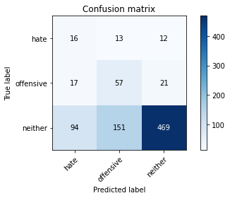

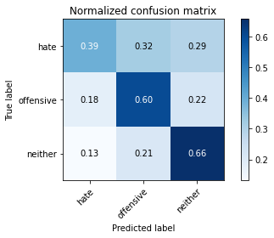

precision recall f1-score support

hate 0.13 0.39 0.19 41

offensive 0.26 0.60 0.36 95

neither 0.93 0.66 0.77 714

accuracy 0.64 850

macro avg 0.44 0.55 0.44 850

weighted avg 0.82 0.64 0.70 850

average eval_loss: 1.4639847995713353, accuracy: 0.6376470588235295

training 18 epoch...

5.604454517364502 seconds used......

18 training finished! average train loss: 0.001536539537482895

evaluating...

Confusion matrix, without normalization

[[ 14 16 11]

[ 10 59 26]

[ 68 161 485]]

Normalized confusion matrix

[[0.34146341 0.3902439 0.26829268]

[0.10526316 0.62105263 0.27368421]

[0.0952381 0.2254902 0.67927171]]

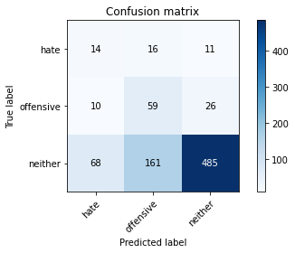

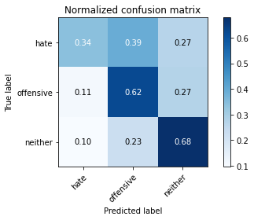

precision recall f1-score support

hate 0.15 0.34 0.21 41

offensive 0.25 0.62 0.36 95

neither 0.93 0.68 0.78 714

accuracy 0.66 850

macro avg 0.44 0.55 0.45 850

weighted avg 0.82 0.66 0.71 850

average eval_loss: 1.442515074112994, accuracy: 0.6564705882352941

training 19 epoch...

5.621040105819702 seconds used......

19 training finished! average train loss: 0.001220802257497174

evaluating...

Confusion matrix, without normalization

[[ 13 17 11]

[ 10 63 22]

[ 61 172 481]]

Normalized confusion matrix

[[0.31707317 0.41463415 0.26829268]

[0.10526316 0.66315789 0.23157895]

[0.08543417 0.24089636 0.67366947]]

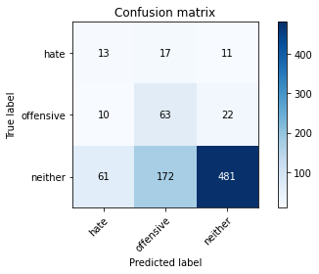

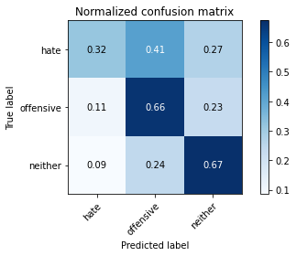

precision recall f1-score support

hate 0.15 0.32 0.21 41

offensive 0.25 0.66 0.36 95

neither 0.94 0.67 0.78 714

accuracy 0.66 850

macro avg 0.45 0.55 0.45 850

weighted avg 0.82 0.66 0.71 850

average eval_loss: 1.5069339240273072, accuracy: 0.6552941176470588

training 20 epoch...

5.646791934967041 seconds used......

20 training finished! average train loss: 0.0011074017044544842

evaluating...

Confusion matrix, without normalization

[[ 10 17 14]

[ 6 61 28]

[ 48 172 494]]

Normalized confusion matrix

[[0.24390244 0.41463415 0.34146341]

[0.06315789 0.64210526 0.29473684]

[0.06722689 0.24089636 0.69187675]]

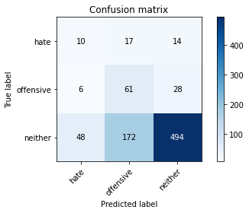

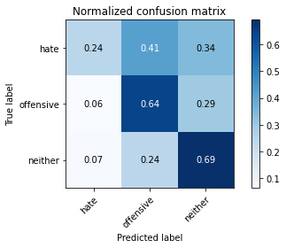

precision recall f1-score support

hate 0.16 0.24 0.19 41

offensive 0.24 0.64 0.35 95

neither 0.92 0.69 0.79 714

accuracy 0.66 850

macro avg 0.44 0.53 0.44 850

weighted avg 0.81 0.66 0.71 850

average eval_loss: 1.4591435587445145, accuracy: 0.6647058823529411

3 run......

training 1 epoch...

5.645031213760376 seconds used......

1 training finished! average train loss: 1.094981516400973

evaluating...

Confusion matrix, without normalization

[[ 0 40 1]

[ 0 92 3]

[ 0 535 179]]

Normalized confusion matrix

[[0. 0.97560976 0.02439024]

[0. 0.96842105 0.03157895]

[0. 0.74929972 0.25070028]]

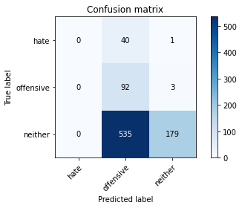

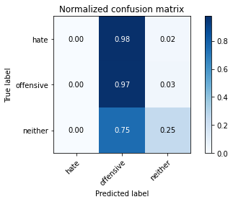

/opt/conda/lib/python3.7/site-packages/sklearn/metrics/_classification.py:1245: UndefinedMetricWarning: Precision and F-score are ill-defined and being set to 0.0 in labels with no predicted samples. Use `zero_division` parameter to control this behavior.

_warn_prf(average, modifier, msg_start, len(result))

/opt/conda/lib/python3.7/site-packages/sklearn/metrics/_classification.py:1245: UndefinedMetricWarning: Precision and F-score are ill-defined and being set to 0.0 in labels with no predicted samples. Use `zero_division` parameter to control this behavior.

_warn_prf(average, modifier, msg_start, len(result))

/opt/conda/lib/python3.7/site-packages/sklearn/metrics/_classification.py:1245: UndefinedMetricWarning: Precision and F-score are ill-defined and being set to 0.0 in labels with no predicted samples. Use `zero_division` parameter to control this behavior.

_warn_prf(average, modifier, msg_start, len(result))

precision recall f1-score support

hate 0.00 0.00 0.00 41

offensive 0.14 0.97 0.24 95

neither 0.98 0.25 0.40 714

accuracy 0.32 850

macro avg 0.37 0.41 0.21 850

weighted avg 0.84 0.32 0.36 850

average eval_loss: 1.0530546162017556, accuracy: 0.31882352941176473

training 2 epoch...

5.608341693878174 seconds used......

2 training finished! average train loss: 0.9497467974821726

evaluating...

Confusion matrix, without normalization

[[ 0 37 4]

[ 0 67 28]

[ 0 310 404]]

Normalized confusion matrix

[[0. 0.90243902 0.09756098]

[0. 0.70526316 0.29473684]

[0. 0.43417367 0.56582633]]

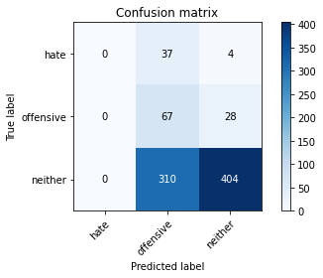

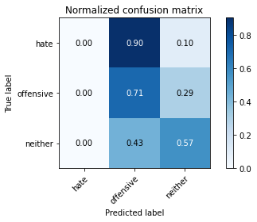

/opt/conda/lib/python3.7/site-packages/sklearn/metrics/_classification.py:1245: UndefinedMetricWarning: Precision and F-score are ill-defined and being set to 0.0 in labels with no predicted samples. Use `zero_division` parameter to control this behavior.

_warn_prf(average, modifier, msg_start, len(result))

/opt/conda/lib/python3.7/site-packages/sklearn/metrics/_classification.py:1245: UndefinedMetricWarning: Precision and F-score are ill-defined and being set to 0.0 in labels with no predicted samples. Use `zero_division` parameter to control this behavior.

_warn_prf(average, modifier, msg_start, len(result))

/opt/conda/lib/python3.7/site-packages/sklearn/metrics/_classification.py:1245: UndefinedMetricWarning: Precision and F-score are ill-defined and being set to 0.0 in labels with no predicted samples. Use `zero_division` parameter to control this behavior.

_warn_prf(average, modifier, msg_start, len(result))

precision recall f1-score support

hate 0.00 0.00 0.00 41

offensive 0.16 0.71 0.26 95

neither 0.93 0.57 0.70 714

accuracy 0.55 850

macro avg 0.36 0.42 0.32 850

weighted avg 0.80 0.55 0.62 850

average eval_loss: 0.8794341832399368, accuracy: 0.5541176470588235

training 3 epoch...

5.620869874954224 seconds used......

3 training finished! average train loss: 0.8085595576299561

evaluating...

Confusion matrix, without normalization

[[ 2 30 9]

[ 3 65 27]

[ 13 205 496]]

Normalized confusion matrix

[[0.04878049 0.73170732 0.2195122 ]

[0.03157895 0.68421053 0.28421053]

[0.01820728 0.28711485 0.69467787]]

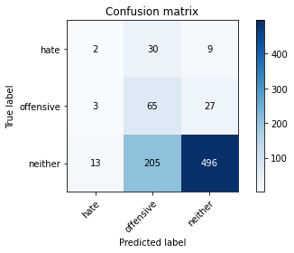

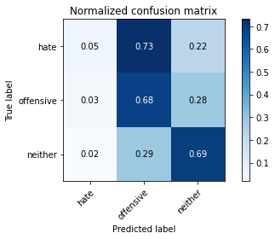

precision recall f1-score support

hate 0.11 0.05 0.07 41

offensive 0.22 0.68 0.33 95

neither 0.93 0.69 0.80 714

accuracy 0.66 850

macro avg 0.42 0.48 0.40 850

weighted avg 0.81 0.66 0.71 850

average eval_loss: 0.7839665925780008, accuracy: 0.6623529411764706

training 4 epoch...

5.5600810050964355 seconds used......

4 training finished! average train loss: 0.6275909195343653

evaluating...

Confusion matrix, without normalization

[[ 0 32 9]

[ 1 69 25]

[ 2 215 497]]

Normalized confusion matrix

[[0. 0.7804878 0.2195122 ]

[0.01052632 0.72631579 0.26315789]

[0.00280112 0.30112045 0.69607843]]

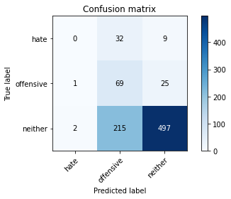

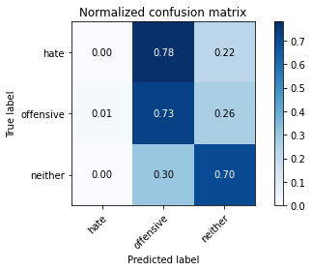

precision recall f1-score support

hate 0.00 0.00 0.00 41

offensive 0.22 0.73 0.34 95

neither 0.94 0.70 0.80 714

accuracy 0.67 850

macro avg 0.38 0.47 0.38 850

weighted avg 0.81 0.67 0.71 850

average eval_loss: 0.7419863569355288, accuracy: 0.6658823529411765

training 5 epoch...

5.5526344776153564 seconds used......

5 training finished! average train loss: 0.4414006844162941

evaluating...

Confusion matrix, without normalization

[[ 5 31 5]

[ 6 75 14]

[ 32 255 427]]

Normalized confusion matrix

[[0.12195122 0.75609756 0.12195122]

[0.06315789 0.78947368 0.14736842]

[0.04481793 0.35714286 0.59803922]]

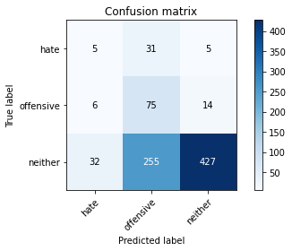

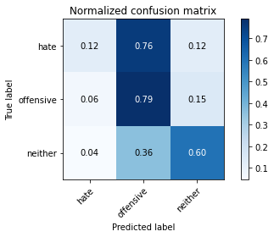

precision recall f1-score support

hate 0.12 0.12 0.12 41

offensive 0.21 0.79 0.33 95

neither 0.96 0.60 0.74 714

accuracy 0.60 850

macro avg 0.43 0.50 0.39 850

weighted avg 0.83 0.60 0.66 850

average eval_loss: 0.9533346986701322, accuracy: 0.5964705882352941

training 6 epoch...

5.594382286071777 seconds used......

6 training finished! average train loss: 0.2201523356553581

evaluating...

Confusion matrix, without normalization

[[ 5 18 18]

[ 4 30 61]

[ 13 110 591]]

Normalized confusion matrix

[[0.12195122 0.43902439 0.43902439]

[0.04210526 0.31578947 0.64210526]

[0.01820728 0.15406162 0.82773109]]

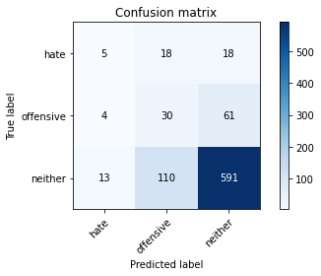

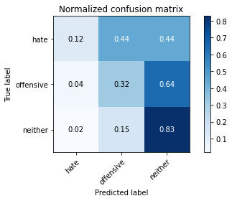

precision recall f1-score support

hate 0.23 0.12 0.16 41

offensive 0.19 0.32 0.24 95

neither 0.88 0.83 0.85 714

accuracy 0.74 850

macro avg 0.43 0.42 0.42 850

weighted avg 0.77 0.74 0.75 850

average eval_loss: 0.6726209762462869, accuracy: 0.7364705882352941

training 7 epoch...

5.690171480178833 seconds used......

7 training finished! average train loss: 0.11319754645228386

evaluating...

Confusion matrix, without normalization

[[ 8 26 7]

[ 8 66 21]

[ 40 217 457]]

Normalized confusion matrix

[[0.19512195 0.63414634 0.17073171]

[0.08421053 0.69473684 0.22105263]

[0.05602241 0.30392157 0.64005602]]

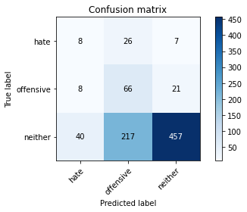

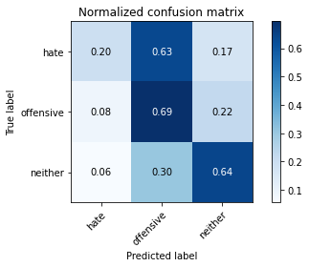

precision recall f1-score support

hate 0.14 0.20 0.16 41

offensive 0.21 0.69 0.33 95

neither 0.94 0.64 0.76 714

accuracy 0.62 850

macro avg 0.43 0.51 0.42 850

weighted avg 0.82 0.62 0.68 850

average eval_loss: 1.1285570749233282, accuracy: 0.6247058823529412

training 8 epoch...

5.604592323303223 seconds used......

8 training finished! average train loss: 0.03977576609597438

evaluating...

Confusion matrix, without normalization

[[ 12 23 6]

[ 15 64 16]

[ 62 193 459]]

Normalized confusion matrix

[[0.29268293 0.56097561 0.14634146]

[0.15789474 0.67368421 0.16842105]

[0.08683473 0.27030812 0.64285714]]

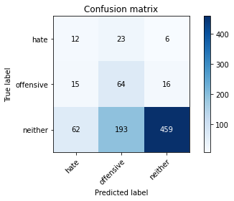

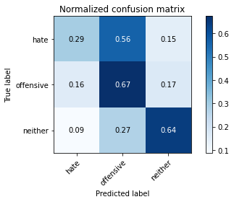

precision recall f1-score support

hate 0.13 0.29 0.18 41

offensive 0.23 0.67 0.34 95

neither 0.95 0.64 0.77 714

accuracy 0.63 850

macro avg 0.44 0.54 0.43 850

weighted avg 0.83 0.63 0.69 850

average eval_loss: 1.2674193366019184, accuracy: 0.6294117647058823

training 9 epoch...

5.580120325088501 seconds used......

9 training finished! average train loss: 0.01711656461055908

evaluating...

Confusion matrix, without normalization

[[ 12 18 11]

[ 13 55 27]

[ 56 148 510]]

Normalized confusion matrix

[[0.29268293 0.43902439 0.26829268]

[0.13684211 0.57894737 0.28421053]

[0.07843137 0.20728291 0.71428571]]

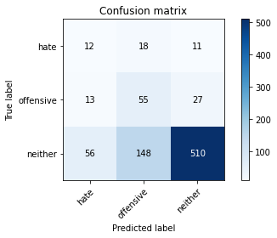

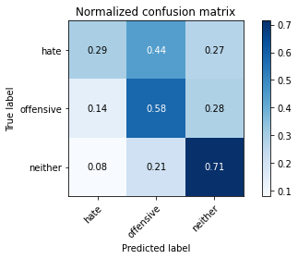

precision recall f1-score support

hate 0.15 0.29 0.20 41

offensive 0.25 0.58 0.35 95

neither 0.93 0.71 0.81 714

accuracy 0.68 850

macro avg 0.44 0.53 0.45 850

weighted avg 0.82 0.68 0.73 850

average eval_loss: 1.1388961614575237, accuracy: 0.6788235294117647

training 10 epoch...

5.583245038986206 seconds used......

10 training finished! average train loss: 0.01095080243734022

evaluating...

Confusion matrix, without normalization

[[ 7 21 13]

[ 9 56 30]

[ 33 170 511]]

Normalized confusion matrix

[[0.17073171 0.51219512 0.31707317]

[0.09473684 0.58947368 0.31578947]

[0.04621849 0.23809524 0.71568627]]

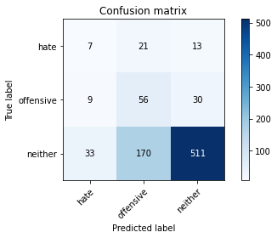

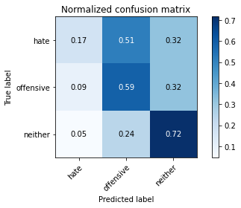

precision recall f1-score support

hate 0.14 0.17 0.16 41

offensive 0.23 0.59 0.33 95

neither 0.92 0.72 0.81 714

accuracy 0.68 850

macro avg 0.43 0.49 0.43 850

weighted avg 0.81 0.68 0.72 850

average eval_loss: 1.1666293609995655, accuracy: 0.6752941176470588

training 11 epoch...

5.597741365432739 seconds used......

11 training finished! average train loss: 0.007077590581805755

evaluating...

Confusion matrix, without normalization

[[ 9 23 9]

[ 12 63 20]

[ 49 186 479]]

Normalized confusion matrix

[[0.2195122 0.56097561 0.2195122 ]

[0.12631579 0.66315789 0.21052632]

[0.06862745 0.2605042 0.67086835]]

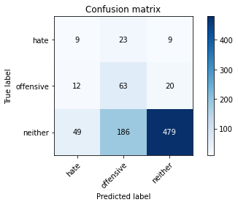

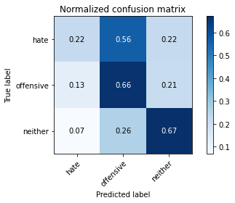

precision recall f1-score support

hate 0.13 0.22 0.16 41

offensive 0.23 0.66 0.34 95

neither 0.94 0.67 0.78 714

accuracy 0.65 850

macro avg 0.43 0.52 0.43 850

weighted avg 0.82 0.65 0.70 850

average eval_loss: 1.3792790042095666, accuracy: 0.648235294117647

training 12 epoch...

5.597108364105225 seconds used......

12 training finished! average train loss: 0.005382805461219202

evaluating...

Confusion matrix, without normalization

[[ 9 23 9]

[ 13 60 22]

[ 53 176 485]]

Normalized confusion matrix

[[0.2195122 0.56097561 0.2195122 ]

[0.13684211 0.63157895 0.23157895]

[0.07422969 0.2464986 0.67927171]]

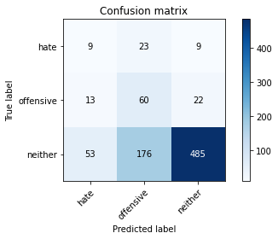

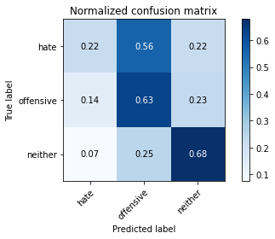

precision recall f1-score support

hate 0.12 0.22 0.16 41

offensive 0.23 0.63 0.34 95

neither 0.94 0.68 0.79 714

accuracy 0.65 850

macro avg 0.43 0.51 0.43 850

weighted avg 0.82 0.65 0.71 850

average eval_loss: 1.4163662490494506, accuracy: 0.6517647058823529

training 13 epoch...

5.625669956207275 seconds used......

13 training finished! average train loss: 0.0035740491536368304

evaluating...

Confusion matrix, without normalization

[[ 8 23 10]

[ 9 63 23]

[ 40 177 497]]

Normalized confusion matrix

[[0.19512195 0.56097561 0.24390244]

[0.09473684 0.66315789 0.24210526]

[0.05602241 0.24789916 0.69607843]]

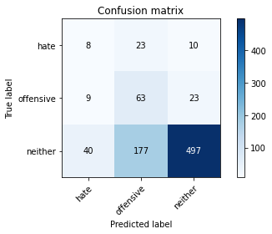

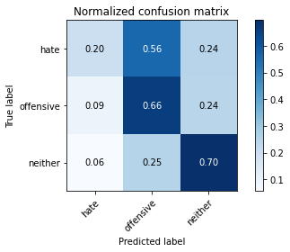

precision recall f1-score support

hate 0.14 0.20 0.16 41

offensive 0.24 0.66 0.35 95

neither 0.94 0.70 0.80 714

accuracy 0.67 850

macro avg 0.44 0.52 0.44 850

weighted avg 0.82 0.67 0.72 850

average eval_loss: 1.3585293552172262, accuracy: 0.668235294117647

training 14 epoch...

5.711278915405273 seconds used......

14 training finished! average train loss: 0.0027225949904984897

evaluating...

Confusion matrix, without normalization

[[ 9 23 9]

[ 10 62 23]

[ 42 174 498]]

Normalized confusion matrix

[[0.2195122 0.56097561 0.2195122 ]

[0.10526316 0.65263158 0.24210526]

[0.05882353 0.24369748 0.69747899]]

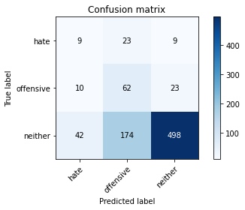

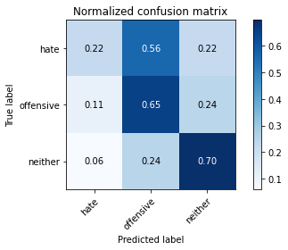

precision recall f1-score support

hate 0.15 0.22 0.18 41

offensive 0.24 0.65 0.35 95

neither 0.94 0.70 0.80 714

accuracy 0.67 850

macro avg 0.44 0.52 0.44 850

weighted avg 0.82 0.67 0.72 850

average eval_loss: 1.4033591076081922, accuracy: 0.6694117647058824

training 15 epoch...

5.544461488723755 seconds used......

15 training finished! average train loss: 0.0025601292048425726

evaluating...

Confusion matrix, without normalization

[[ 9 20 12]

[ 10 60 25]

[ 38 169 507]]

Normalized confusion matrix

[[0.2195122 0.48780488 0.29268293]

[0.10526316 0.63157895 0.26315789]

[0.05322129 0.23669468 0.71008403]]

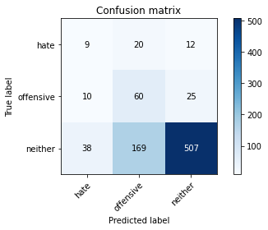

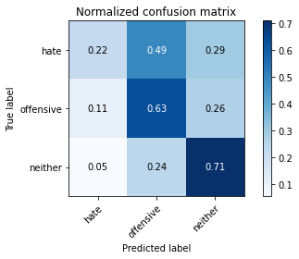

precision recall f1-score support

hate 0.16 0.22 0.18 41

offensive 0.24 0.63 0.35 95

neither 0.93 0.71 0.81 714

accuracy 0.68 850

macro avg 0.44 0.52 0.45 850

weighted avg 0.82 0.68 0.72 850

average eval_loss: 1.3539549008371894, accuracy: 0.6776470588235294

training 16 epoch...

5.551153659820557 seconds used......

16 training finished! average train loss: 0.0024988279555044654

evaluating...

Confusion matrix, without normalization

[[ 8 24 9]

[ 9 66 20]

[ 35 197 482]]

Normalized confusion matrix

[[0.19512195 0.58536585 0.2195122 ]

[0.09473684 0.69473684 0.21052632]

[0.04901961 0.27591036 0.67507003]]

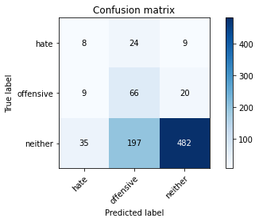

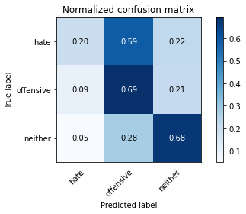

precision recall f1-score support

hate 0.15 0.20 0.17 41

offensive 0.23 0.69 0.35 95

neither 0.94 0.68 0.79 714

accuracy 0.65 850

macro avg 0.44 0.52 0.43 850

weighted avg 0.83 0.65 0.71 850

average eval_loss: 1.544693904701447, accuracy: 0.6541176470588236

training 17 epoch...

5.54118537902832 seconds used......

17 training finished! average train loss: 0.001995932128112246

evaluating...

Confusion matrix, without normalization

[[ 7 20 14]

[ 9 58 28]

[ 32 167 515]]

Normalized confusion matrix

[[0.17073171 0.48780488 0.34146341]

[0.09473684 0.61052632 0.29473684]

[0.04481793 0.23389356 0.72128852]]

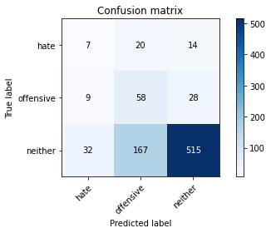

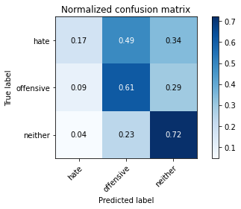

precision recall f1-score support

hate 0.15 0.17 0.16 41

offensive 0.24 0.61 0.34 95

neither 0.92 0.72 0.81 714

accuracy 0.68 850

macro avg 0.44 0.50 0.44 850

weighted avg 0.81 0.68 0.73 850

average eval_loss: 1.3467035749142036, accuracy: 0.6823529411764706

training 18 epoch...

5.742522954940796 seconds used......

18 training finished! average train loss: 0.0016035938072794427

evaluating...

Confusion matrix, without normalization

[[ 7 21 13]

[ 11 58 26]

[ 35 172 507]]

Normalized confusion matrix

[[0.17073171 0.51219512 0.31707317]

[0.11578947 0.61052632 0.27368421]

[0.04901961 0.24089636 0.71008403]]

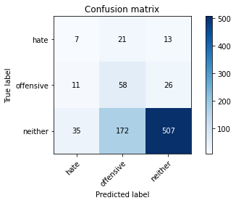

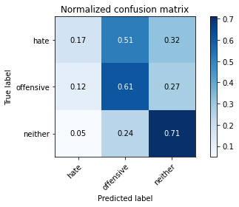

precision recall f1-score support

hate 0.13 0.17 0.15 41

offensive 0.23 0.61 0.34 95

neither 0.93 0.71 0.80 714

accuracy 0.67 850

macro avg 0.43 0.50 0.43 850

weighted avg 0.81 0.67 0.72 850

average eval_loss: 1.4234338532984365, accuracy: 0.6729411764705883

training 19 epoch...

5.617294788360596 seconds used......

19 training finished! average train loss: 0.0015607112873112783

evaluating...

Confusion matrix, without normalization

[[ 9 20 12]

[ 11 60 24]

[ 39 170 505]]

Normalized confusion matrix

[[0.2195122 0.48780488 0.29268293]

[0.11578947 0.63157895 0.25263158]

[0.05462185 0.23809524 0.70728291]]

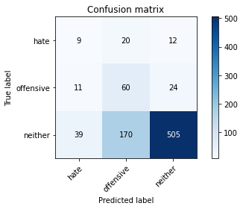

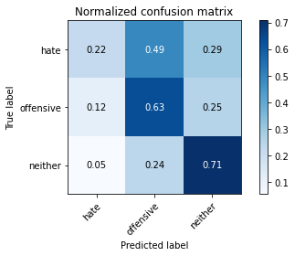

precision recall f1-score support

hate 0.15 0.22 0.18 41

offensive 0.24 0.63 0.35 95

neither 0.93 0.71 0.80 714

accuracy 0.68 850

macro avg 0.44 0.52 0.44 850

weighted avg 0.82 0.68 0.72 850

average eval_loss: 1.4751801096650143, accuracy: 0.6752941176470588

training 20 epoch...

5.632312774658203 seconds used......

20 training finished! average train loss: 0.001329894447634514

evaluating...

Confusion matrix, without normalization

[[ 9 20 12]

[ 11 58 26]

[ 39 169 506]]

Normalized confusion matrix

[[0.2195122 0.48780488 0.29268293]

[0.11578947 0.61052632 0.27368421]

[0.05462185 0.23669468 0.70868347]]

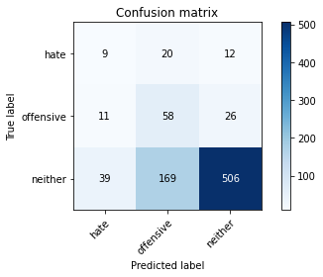

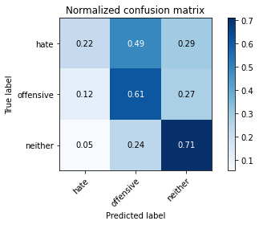

precision recall f1-score support

hate 0.15 0.22 0.18 41

offensive 0.23 0.61 0.34 95

neither 0.93 0.71 0.80 714

accuracy 0.67 850

macro avg 0.44 0.51 0.44 850

weighted avg 0.81 0.67 0.72 850

average eval_loss: 1.478272883859084, accuracy: 0.6741176470588235

4 run......

training 1 epoch...

5.691935777664185 seconds used......

1 training finished! average train loss: 1.1160008758306503

evaluating...

Confusion matrix, without normalization

[[ 0 40 1]

[ 0 92 3]

[ 0 592 122]]

Normalized confusion matrix

[[0. 0.97560976 0.02439024]

[0. 0.96842105 0.03157895]

[0. 0.82913165 0.17086835]]

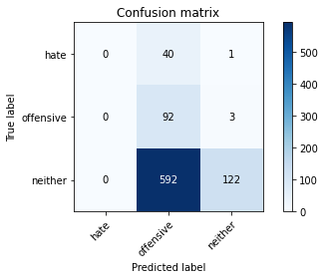

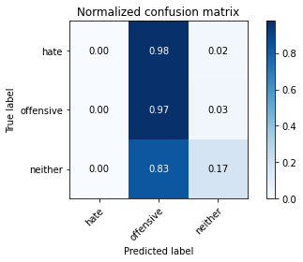

/opt/conda/lib/python3.7/site-packages/sklearn/metrics/_classification.py:1245: UndefinedMetricWarning: Precision and F-score are ill-defined and being set to 0.0 in labels with no predicted samples. Use `zero_division` parameter to control this behavior.

_warn_prf(average, modifier, msg_start, len(result))

/opt/conda/lib/python3.7/site-packages/sklearn/metrics/_classification.py:1245: UndefinedMetricWarning: Precision and F-score are ill-defined and being set to 0.0 in labels with no predicted samples. Use `zero_division` parameter to control this behavior.

_warn_prf(average, modifier, msg_start, len(result))

/opt/conda/lib/python3.7/site-packages/sklearn/metrics/_classification.py:1245: UndefinedMetricWarning: Precision and F-score are ill-defined and being set to 0.0 in labels with no predicted samples. Use `zero_division` parameter to control this behavior.

_warn_prf(average, modifier, msg_start, len(result))

precision recall f1-score support

hate 0.00 0.00 0.00 41

offensive 0.13 0.97 0.22 95

neither 0.97 0.17 0.29 714

accuracy 0.25 850

macro avg 0.37 0.38 0.17 850

weighted avg 0.83 0.25 0.27 850

average eval_loss: 1.0027108857798022, accuracy: 0.25176470588235295

training 2 epoch...

5.604482650756836 seconds used......

2 training finished! average train loss: 0.9407413138283623

evaluating...

Confusion matrix, without normalization

[[ 1 39 1]

[ 0 82 13]

[ 1 401 312]]

Normalized confusion matrix

[[0.02439024 0.95121951 0.02439024]

[0. 0.86315789 0.13684211]

[0.00140056 0.56162465 0.43697479]]

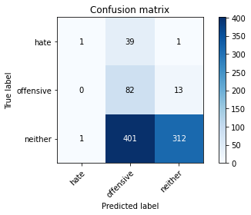

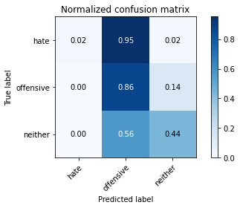

precision recall f1-score support

hate 0.50 0.02 0.05 41

offensive 0.16 0.86 0.27 95

neither 0.96 0.44 0.60 714

accuracy 0.46 850

macro avg 0.54 0.44 0.30 850

weighted avg 0.85 0.46 0.54 850

average eval_loss: 0.916756100779356, accuracy: 0.4647058823529412

training 3 epoch...

5.577089071273804 seconds used......

3 training finished! average train loss: 0.801844995882776

evaluating...

Confusion matrix, without normalization

[[ 6 21 14]

[ 5 47 43]

[ 26 167 521]]

Normalized confusion matrix

[[0.14634146 0.51219512 0.34146341]

[0.05263158 0.49473684 0.45263158]

[0.03641457 0.23389356 0.72969188]]

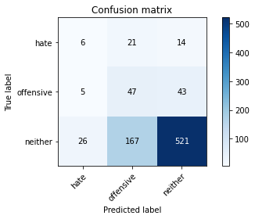

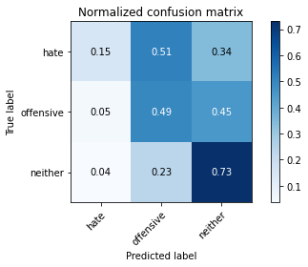

precision recall f1-score support

hate 0.16 0.15 0.15 41

offensive 0.20 0.49 0.28 95

neither 0.90 0.73 0.81 714

accuracy 0.68 850

macro avg 0.42 0.46 0.42 850

weighted avg 0.79 0.68 0.72 850

average eval_loss: 0.7440716624259949, accuracy: 0.6752941176470588

training 4 epoch...

5.624919176101685 seconds used......

4 training finished! average train loss: 0.6268531688385539

evaluating...

Confusion matrix, without normalization

[[ 11 10 20]

[ 10 25 60]

[ 36 83 595]]

Normalized confusion matrix

[[0.26829268 0.24390244 0.48780488]

[0.10526316 0.26315789 0.63157895]

[0.05042017 0.1162465 0.83333333]]

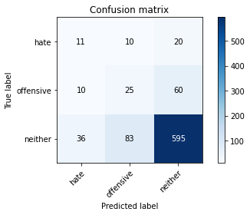

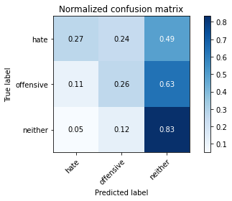

precision recall f1-score support

hate 0.19 0.27 0.22 41

offensive 0.21 0.26 0.23 95

neither 0.88 0.83 0.86 714

accuracy 0.74 850

macro avg 0.43 0.45 0.44 850

weighted avg 0.77 0.74 0.76 850

average eval_loss: 0.6360758601059747, accuracy: 0.7423529411764705

training 5 epoch...

5.54839563369751 seconds used......

5 training finished! average train loss: 0.4454602251450221

evaluating...

Confusion matrix, without normalization

[[ 9 28 4]

[ 10 80 5]

[ 61 336 317]]

Normalized confusion matrix

[[0.2195122 0.68292683 0.09756098]

[0.10526316 0.84210526 0.05263158]

[0.08543417 0.47058824 0.44397759]]

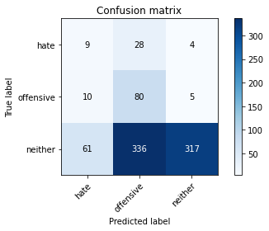

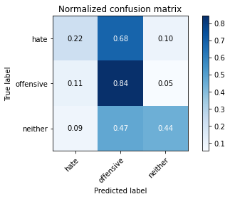

precision recall f1-score support

hate 0.11 0.22 0.15 41

offensive 0.18 0.84 0.30 95

neither 0.97 0.44 0.61 714

accuracy 0.48 850

macro avg 0.42 0.50 0.35 850

weighted avg 0.84 0.48 0.55 850

average eval_loss: 1.2769400626420975, accuracy: 0.4776470588235294

training 6 epoch...

5.578592300415039 seconds used......

6 training finished! average train loss: 0.289115104617344

evaluating...

Confusion matrix, without normalization

[[ 12 14 15]

[ 11 57 27]

[ 57 144 513]]

Normalized confusion matrix

[[0.29268293 0.34146341 0.36585366]

[0.11578947 0.6 0.28421053]

[0.07983193 0.20168067 0.71848739]]

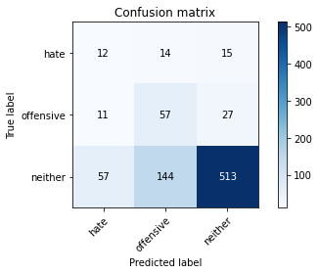

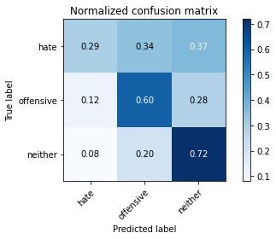

precision recall f1-score support

hate 0.15 0.29 0.20 41

offensive 0.27 0.60 0.37 95

neither 0.92 0.72 0.81 714

accuracy 0.68 850

macro avg 0.45 0.54 0.46 850

weighted avg 0.81 0.68 0.73 850

average eval_loss: 0.8119177837357965, accuracy: 0.6847058823529412

training 7 epoch...

5.579535245895386 seconds used......

7 training finished! average train loss: 0.11708991206251085

evaluating...

Confusion matrix, without normalization

[[ 7 17 17]

[ 2 39 54]

[ 10 132 572]]

Normalized confusion matrix

[[0.17073171 0.41463415 0.41463415]

[0.02105263 0.41052632 0.56842105]

[0.0140056 0.18487395 0.80112045]]

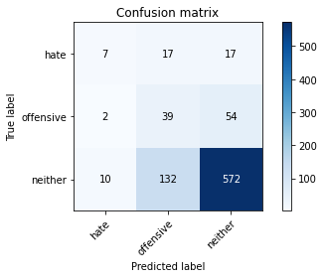

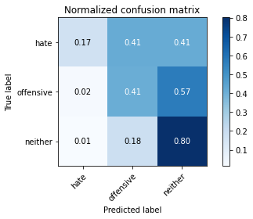

precision recall f1-score support

hate 0.37 0.17 0.23 41

offensive 0.21 0.41 0.28 95

neither 0.89 0.80 0.84 714

accuracy 0.73 850

macro avg 0.49 0.46 0.45 850

weighted avg 0.79 0.73 0.75 850

average eval_loss: 0.8085128173751887, accuracy: 0.7270588235294118

training 8 epoch...

5.649632692337036 seconds used......

8 training finished! average train loss: 0.04843158370608257

evaluating...

Confusion matrix, without normalization

[[ 14 11 16]

[ 13 48 34]

[ 82 123 509]]

Normalized confusion matrix

[[0.34146341 0.26829268 0.3902439 ]

[0.13684211 0.50526316 0.35789474]

[0.11484594 0.17226891 0.71288515]]

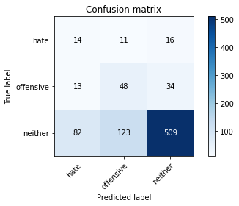

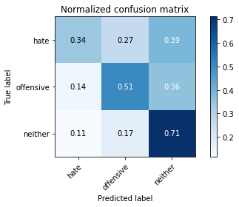

precision recall f1-score support

hate 0.13 0.34 0.19 41

offensive 0.26 0.51 0.35 95

neither 0.91 0.71 0.80 714

accuracy 0.67 850

macro avg 0.43 0.52 0.44 850

weighted avg 0.80 0.67 0.72 850

average eval_loss: 1.0295869411120928, accuracy: 0.6717647058823529

training 9 epoch...

5.575352907180786 seconds used......

9 training finished! average train loss: 0.02490958479595267

evaluating...

Confusion matrix, without normalization

[[ 8 14 19]

[ 7 48 40]

[ 21 126 567]]

Normalized confusion matrix

[[0.19512195 0.34146341 0.46341463]

[0.07368421 0.50526316 0.42105263]

[0.02941176 0.17647059 0.79411765]]

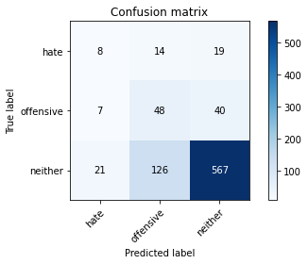

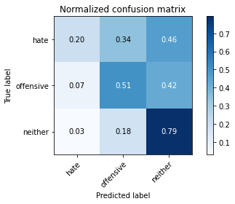

precision recall f1-score support

hate 0.22 0.20 0.21 41

offensive 0.26 0.51 0.34 95

neither 0.91 0.79 0.85 714

accuracy 0.73 850

macro avg 0.46 0.50 0.46 850

weighted avg 0.80 0.73 0.76 850

average eval_loss: 0.8975539137609303, accuracy: 0.7329411764705882

training 10 epoch...

5.583327531814575 seconds used......

10 training finished! average train loss: 0.011958479079314403

evaluating...

Confusion matrix, without normalization

[[ 14 12 15]

[ 13 54 28]

[ 77 151 486]]

Normalized confusion matrix

[[0.34146341 0.29268293 0.36585366]

[0.13684211 0.56842105 0.29473684]

[0.10784314 0.21148459 0.68067227]]

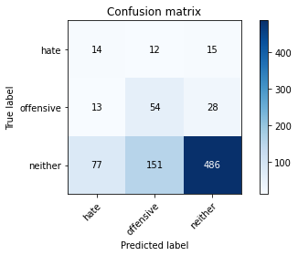

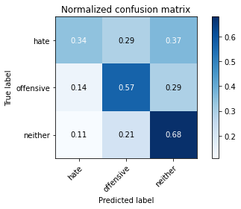

precision recall f1-score support

hate 0.13 0.34 0.19 41

offensive 0.25 0.57 0.35 95

neither 0.92 0.68 0.78 714

accuracy 0.65 850

macro avg 0.43 0.53 0.44 850

weighted avg 0.81 0.65 0.70 850

average eval_loss: 1.2415998613375216, accuracy: 0.6517647058823529

training 11 epoch...

5.643464088439941 seconds used......

11 training finished! average train loss: 0.006752833161347856

evaluating...

Confusion matrix, without normalization

[[ 10 14 17]

[ 9 56 30]

[ 42 155 517]]

Normalized confusion matrix

[[0.24390244 0.34146341 0.41463415]

[0.09473684 0.58947368 0.31578947]

[0.05882353 0.21708683 0.72408964]]

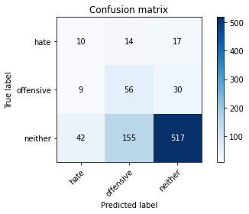

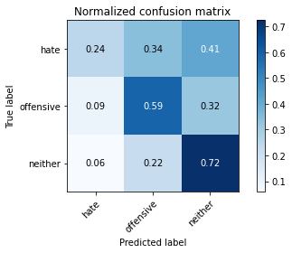

precision recall f1-score support

hate 0.16 0.24 0.20 41

offensive 0.25 0.59 0.35 95

neither 0.92 0.72 0.81 714

accuracy 0.69 850

macro avg 0.44 0.52 0.45 850

weighted avg 0.81 0.69 0.73 850

average eval_loss: 1.2054416747049017, accuracy: 0.6858823529411765

training 12 epoch...

5.652441740036011 seconds used......

12 training finished! average train loss: 0.003934638377460133

evaluating...

Confusion matrix, without normalization

[[ 11 13 17]

[ 9 54 32]

[ 44 146 524]]

Normalized confusion matrix

[[0.26829268 0.31707317 0.41463415]

[0.09473684 0.56842105 0.33684211]

[0.06162465 0.20448179 0.73389356]]

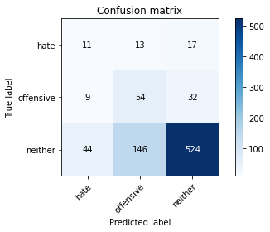

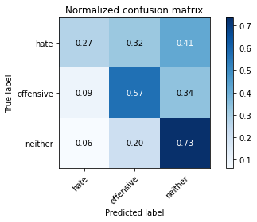

precision recall f1-score support

hate 0.17 0.27 0.21 41

offensive 0.25 0.57 0.35 95

neither 0.91 0.73 0.81 714

accuracy 0.69 850

macro avg 0.45 0.52 0.46 850

weighted avg 0.80 0.69 0.73 850

average eval_loss: 1.2205835295689487, accuracy: 0.6929411764705883

training 13 epoch...

5.622051239013672 seconds used......

13 training finished! average train loss: 0.003258056781810915

evaluating...

Confusion matrix, without normalization

[[ 8 16 17]

[ 8 58 29]

[ 37 158 519]]

Normalized confusion matrix

[[0.19512195 0.3902439 0.41463415]

[0.08421053 0.61052632 0.30526316]

[0.05182073 0.22128852 0.72689076]]

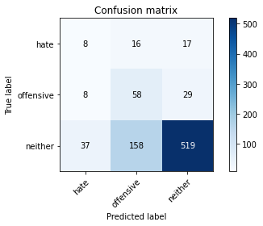

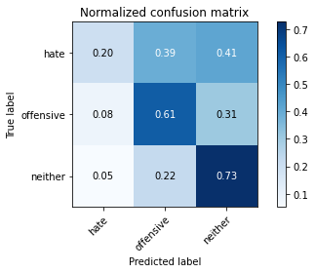

precision recall f1-score support

hate 0.15 0.20 0.17 41

offensive 0.25 0.61 0.35 95

neither 0.92 0.73 0.81 714

accuracy 0.69 850

macro avg 0.44 0.51 0.45 850

weighted avg 0.81 0.69 0.73 850

average eval_loss: 1.2746874365933933, accuracy: 0.6882352941176471

training 14 epoch...

5.600024700164795 seconds used......

14 training finished! average train loss: 0.0064589369236879675

evaluating...

Confusion matrix, without normalization

[[ 11 13 17]

[ 8 43 44]

[ 34 111 569]]

Normalized confusion matrix

[[0.26829268 0.31707317 0.41463415]

[0.08421053 0.45263158 0.46315789]

[0.04761905 0.15546218 0.79691877]]

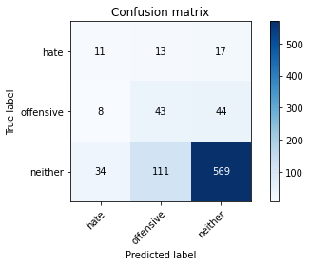

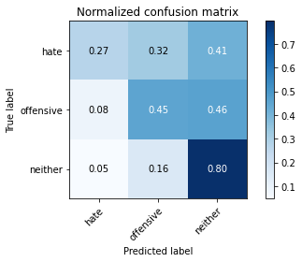

precision recall f1-score support

hate 0.21 0.27 0.23 41

offensive 0.26 0.45 0.33 95

neither 0.90 0.80 0.85 714

accuracy 0.73 850

macro avg 0.46 0.51 0.47 850

weighted avg 0.80 0.73 0.76 850

average eval_loss: 1.0576136620921017, accuracy: 0.7329411764705882

training 15 epoch...

5.62906289100647 seconds used......

15 training finished! average train loss: 0.004656037978646863

evaluating...

Confusion matrix, without normalization

[[ 8 16 17]

[ 2 40 53]

[ 18 121 575]]

Normalized confusion matrix

[[0.19512195 0.3902439 0.41463415]

[0.02105263 0.42105263 0.55789474]

[0.02521008 0.16946779 0.80532213]]

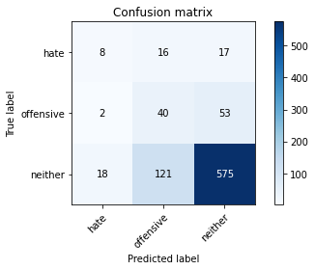

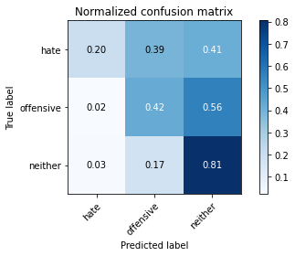

precision recall f1-score support

hate 0.29 0.20 0.23 41

offensive 0.23 0.42 0.29 95

neither 0.89 0.81 0.85 714

accuracy 0.73 850

macro avg 0.47 0.47 0.46 850

weighted avg 0.79 0.73 0.75 850

average eval_loss: 1.0994630751503243, accuracy: 0.7329411764705882

training 16 epoch...

5.541476249694824 seconds used......

16 training finished! average train loss: 0.0030238408265480152

evaluating...

Confusion matrix, without normalization

[[ 14 14 13]

[ 9 63 23]

[ 59 159 496]]

Normalized confusion matrix

[[0.34146341 0.34146341 0.31707317]

[0.09473684 0.66315789 0.24210526]

[0.08263305 0.22268908 0.69467787]]

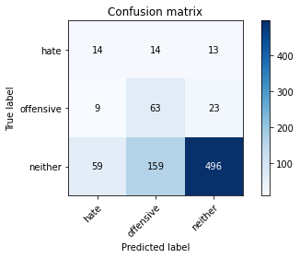

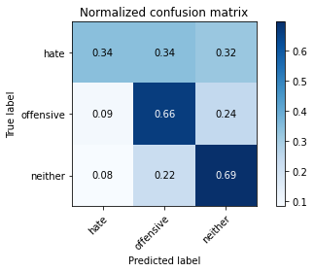

precision recall f1-score support

hate 0.17 0.34 0.23 41

offensive 0.27 0.66 0.38 95

neither 0.93 0.69 0.80 714

accuracy 0.67 850

macro avg 0.46 0.57 0.47 850

weighted avg 0.82 0.67 0.72 850

average eval_loss: 1.479694891320325, accuracy: 0.6741176470588235

training 17 epoch...

5.553698778152466 seconds used......

17 training finished! average train loss: 0.002611056804501762

evaluating...

Confusion matrix, without normalization

[[ 14 12 15]

[ 9 59 27]

[ 64 137 513]]

Normalized confusion matrix

[[0.34146341 0.29268293 0.36585366]

[0.09473684 0.62105263 0.28421053]

[0.08963585 0.19187675 0.71848739]]

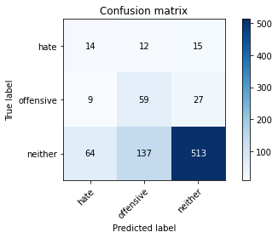

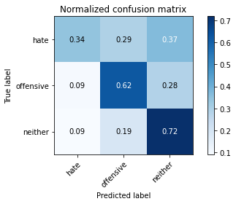

precision recall f1-score support

hate 0.16 0.34 0.22 41

offensive 0.28 0.62 0.39 95

neither 0.92 0.72 0.81 714

accuracy 0.69 850

macro avg 0.46 0.56 0.47 850

weighted avg 0.82 0.69 0.73 850

average eval_loss: 1.4180211878143425, accuracy: 0.6894117647058824

training 18 epoch...

5.575294017791748 seconds used......

18 training finished! average train loss: 0.001646215050843441

evaluating...

Confusion matrix, without normalization

[[ 10 14 17]

[ 6 54 35]

[ 41 141 532]]

Normalized confusion matrix

[[0.24390244 0.34146341 0.41463415]

[0.06315789 0.56842105 0.36842105]

[0.05742297 0.19747899 0.74509804]]

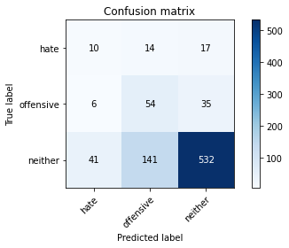

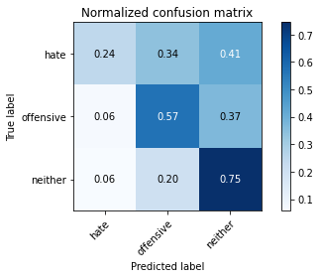

precision recall f1-score support

hate 0.18 0.24 0.20 41

offensive 0.26 0.57 0.36 95

neither 0.91 0.75 0.82 714

accuracy 0.70 850

macro avg 0.45 0.52 0.46 850

weighted avg 0.80 0.70 0.74 850

average eval_loss: 1.3392768462112736, accuracy: 0.7011764705882353

training 19 epoch...

5.6597511768341064 seconds used......

19 training finished! average train loss: 0.001595974500459205

evaluating...

Confusion matrix, without normalization

[[ 11 13 17]

[ 7 54 34]

[ 57 130 527]]

Normalized confusion matrix

[[0.26829268 0.31707317 0.41463415]

[0.07368421 0.56842105 0.35789474]

[0.07983193 0.18207283 0.73809524]]

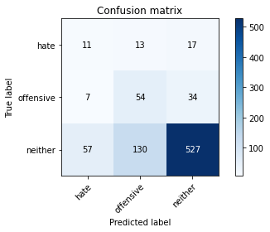

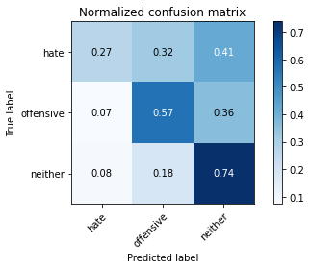

precision recall f1-score support

hate 0.15 0.27 0.19 41

offensive 0.27 0.57 0.37 95

neither 0.91 0.74 0.82 714

accuracy 0.70 850

macro avg 0.44 0.52 0.46 850

weighted avg 0.80 0.70 0.74 850

average eval_loss: 1.3944633507473005, accuracy: 0.6964705882352941

training 20 epoch...

5.596716403961182 seconds used......

20 training finished! average train loss: 0.0012128033914551553

evaluating...

Confusion matrix, without normalization

[[ 11 16 14]

[ 6 66 23]

[ 52 176 486]]

Normalized confusion matrix

[[0.26829268 0.3902439 0.34146341]

[0.06315789 0.69473684 0.24210526]

[0.07282913 0.2464986 0.68067227]]

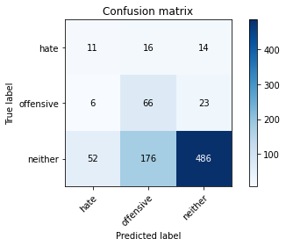

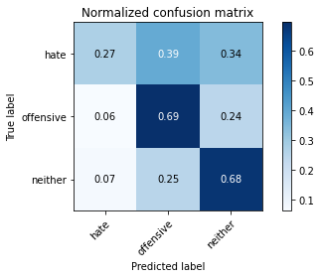

precision recall f1-score support

hate 0.16 0.27 0.20 41

offensive 0.26 0.69 0.37 95

neither 0.93 0.68 0.79 714

accuracy 0.66 850

macro avg 0.45 0.55 0.45 850

weighted avg 0.82 0.66 0.71 850

average eval_loss: 1.6424529812255397, accuracy: 0.6623529411764706

5 run......

training 1 epoch...

5.630265474319458 seconds used......

1 training finished! average train loss: 1.0708129207293193

evaluating...

Confusion matrix, without normalization

[[ 0 35 6]

[ 0 65 30]

[ 0 338 376]]

Normalized confusion matrix

[[0. 0.85365854 0.14634146]

[0. 0.68421053 0.31578947]

[0. 0.47338936 0.52661064]]

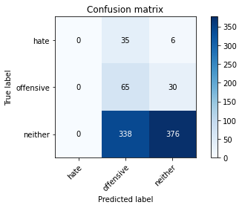

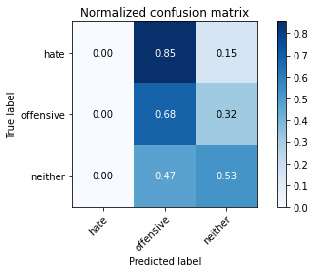

/opt/conda/lib/python3.7/site-packages/sklearn/metrics/_classification.py:1245: UndefinedMetricWarning: Precision and F-score are ill-defined and being set to 0.0 in labels with no predicted samples. Use `zero_division` parameter to control this behavior.

_warn_prf(average, modifier, msg_start, len(result))

/opt/conda/lib/python3.7/site-packages/sklearn/metrics/_classification.py:1245: UndefinedMetricWarning: Precision and F-score are ill-defined and being set to 0.0 in labels with no predicted samples. Use `zero_division` parameter to control this behavior.

_warn_prf(average, modifier, msg_start, len(result))

/opt/conda/lib/python3.7/site-packages/sklearn/metrics/_classification.py:1245: UndefinedMetricWarning: Precision and F-score are ill-defined and being set to 0.0 in labels with no predicted samples. Use `zero_division` parameter to control this behavior.

_warn_prf(average, modifier, msg_start, len(result))

precision recall f1-score support

hate 0.00 0.00 0.00 41

offensive 0.15 0.68 0.24 95

neither 0.91 0.53 0.67 714

accuracy 0.52 850

macro avg 0.35 0.40 0.30 850

weighted avg 0.78 0.52 0.59 850

average eval_loss: 0.8843529439249704, accuracy: 0.5188235294117647

training 2 epoch...

5.667649030685425 seconds used......

2 training finished! average train loss: 0.9571022705899345

evaluating...

Confusion matrix, without normalization

[[ 0 36 5]

[ 0 79 16]

[ 1 324 389]]

Normalized confusion matrix

[[0. 0.87804878 0.12195122]

[0. 0.83157895 0.16842105]

[0.00140056 0.45378151 0.54481793]]

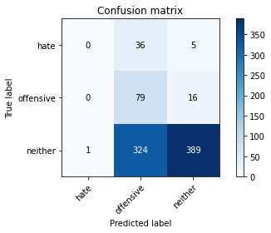

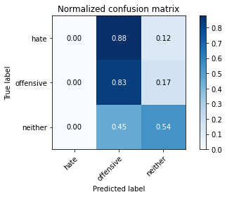

precision recall f1-score support

hate 0.00 0.00 0.00 41

offensive 0.18 0.83 0.30 95

neither 0.95 0.54 0.69 714

accuracy 0.55 850

macro avg 0.38 0.46 0.33 850

weighted avg 0.82 0.55 0.61 850

average eval_loss: 0.8911016035911649, accuracy: 0.5505882352941176

training 3 epoch...

5.574459075927734 seconds used......

3 training finished! average train loss: 0.8499752581119537

evaluating...

Confusion matrix, without normalization

[[ 0 30 11]

[ 0 82 13]

[ 2 276 436]]

Normalized confusion matrix

[[0. 0.73170732 0.26829268]

[0. 0.86315789 0.13684211]

[0.00280112 0.38655462 0.61064426]]

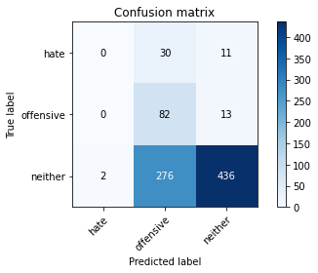

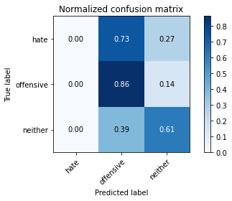

precision recall f1-score support

hate 0.00 0.00 0.00 41

offensive 0.21 0.86 0.34 95

neither 0.95 0.61 0.74 714

accuracy 0.61 850

macro avg 0.39 0.49 0.36 850

weighted avg 0.82 0.61 0.66 850

average eval_loss: 0.8334882980169251, accuracy: 0.6094117647058823

training 4 epoch...

5.571308374404907 seconds used......

4 training finished! average train loss: 0.6760447108083301

evaluating...

Confusion matrix, without normalization

[[ 11 13 17]

[ 5 53 37]

[ 42 149 523]]

Normalized confusion matrix

[[0.26829268 0.31707317 0.41463415]

[0.05263158 0.55789474 0.38947368]

[0.05882353 0.20868347 0.732493 ]]

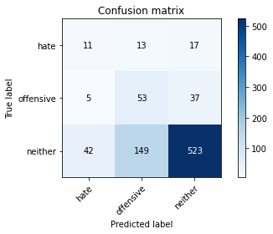

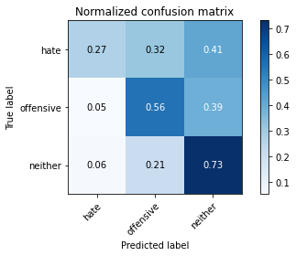

precision recall f1-score support

hate 0.19 0.27 0.22 41

offensive 0.25 0.56 0.34 95

neither 0.91 0.73 0.81 714

accuracy 0.69 850

macro avg 0.45 0.52 0.46 850

weighted avg 0.80 0.69 0.73 850

average eval_loss: 0.720349118286787, accuracy: 0.6905882352941176

training 5 epoch...

5.571317195892334 seconds used......

5 training finished! average train loss: 0.46564720736609566

evaluating...

Confusion matrix, without normalization

[[ 13 17 11]

[ 13 75 7]

[ 87 244 383]]

Normalized confusion matrix

[[0.31707317 0.41463415 0.26829268]

[0.13684211 0.78947368 0.07368421]

[0.12184874 0.34173669 0.53641457]]

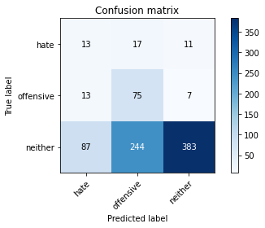

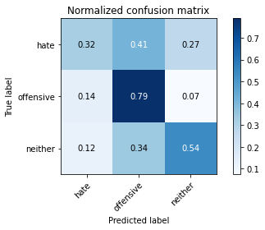

precision recall f1-score support

hate 0.12 0.32 0.17 41

offensive 0.22 0.79 0.35 95

neither 0.96 0.54 0.69 714

accuracy 0.55 850

macro avg 0.43 0.55 0.40 850

weighted avg 0.83 0.55 0.62 850

average eval_loss: 1.080574288617733, accuracy: 0.5541176470588235

training 6 epoch...

5.590777158737183 seconds used......

6 training finished! average train loss: 0.2701408473981751

evaluating...

Confusion matrix, without normalization

[[ 16 10 15]

[ 20 37 38]

[ 87 136 491]]

Normalized confusion matrix

[[0.3902439 0.24390244 0.36585366]

[0.21052632 0.38947368 0.4 ]

[0.12184874 0.19047619 0.68767507]]

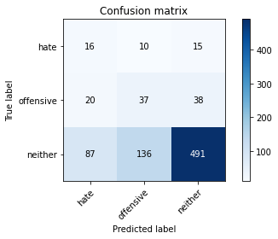

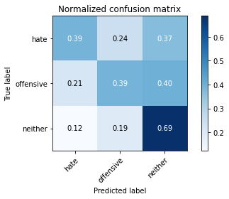

precision recall f1-score support

hate 0.13 0.39 0.20 41

offensive 0.20 0.39 0.27 95

neither 0.90 0.69 0.78 714

accuracy 0.64 850

macro avg 0.41 0.49 0.41 850

weighted avg 0.79 0.64 0.69 850

average eval_loss: 0.9315251358893029, accuracy: 0.64

training 7 epoch...

5.572986364364624 seconds used......

7 training finished! average train loss: 0.13040462870978647

evaluating...

Confusion matrix, without normalization

[[ 13 15 13]

[ 15 48 32]

[ 94 183 437]]

Normalized confusion matrix

[[0.31707317 0.36585366 0.31707317]

[0.15789474 0.50526316 0.33684211]

[0.13165266 0.25630252 0.61204482]]

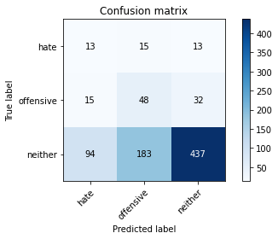

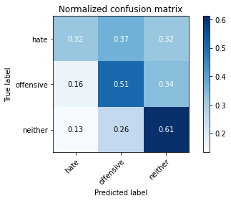

precision recall f1-score support

hate 0.11 0.32 0.16 41

offensive 0.20 0.51 0.28 95

neither 0.91 0.61 0.73 714

accuracy 0.59 850

macro avg 0.40 0.48 0.39 850

weighted avg 0.79 0.59 0.65 850

average eval_loss: 1.1666881351969962, accuracy: 0.5858823529411765

training 8 epoch...

5.592822074890137 seconds used......

8 training finished! average train loss: 0.042456219179762736

evaluating...

Confusion matrix, without normalization

[[ 11 17 13]

[ 7 69 19]

[ 71 196 447]]

Normalized confusion matrix

[[0.26829268 0.41463415 0.31707317]

[0.07368421 0.72631579 0.2 ]

[0.09943978 0.2745098 0.62605042]]

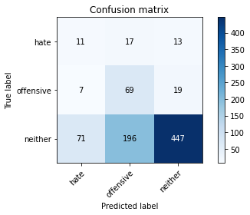

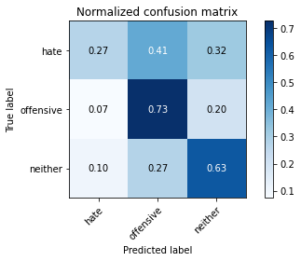

precision recall f1-score support

hate 0.12 0.27 0.17 41

offensive 0.24 0.73 0.37 95

neither 0.93 0.63 0.75 714

accuracy 0.62 850

macro avg 0.43 0.54 0.43 850

weighted avg 0.82 0.62 0.68 850

average eval_loss: 1.2257164108978456, accuracy: 0.62

training 9 epoch...

5.59834361076355 seconds used......

9 training finished! average train loss: 0.020703080375420138

evaluating...

Confusion matrix, without normalization

[[ 10 19 12]

[ 6 72 17]

[ 60 218 436]]

Normalized confusion matrix

[[0.24390244 0.46341463 0.29268293]

[0.06315789 0.75789474 0.17894737]

[0.08403361 0.30532213 0.61064426]]

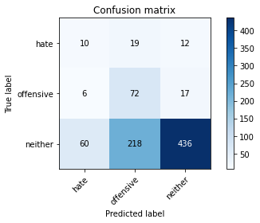

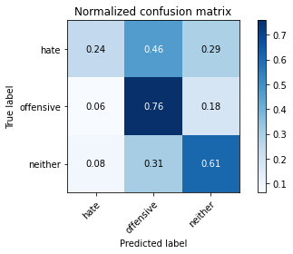

precision recall f1-score support

hate 0.13 0.24 0.17 41

offensive 0.23 0.76 0.36 95

neither 0.94 0.61 0.74 714

accuracy 0.61 850

macro avg 0.43 0.54 0.42 850

weighted avg 0.82 0.61 0.67 850

average eval_loss: 1.35796624136179, accuracy: 0.6094117647058823

training 10 epoch...

5.586417198181152 seconds used......

10 training finished! average train loss: 0.01090884977667075

evaluating...

Confusion matrix, without normalization

[[ 10 18 13]

[ 8 69 18]

[ 61 197 456]]

Normalized confusion matrix

[[0.24390244 0.43902439 0.31707317]

[0.08421053 0.72631579 0.18947368]

[0.08543417 0.27591036 0.63865546]]

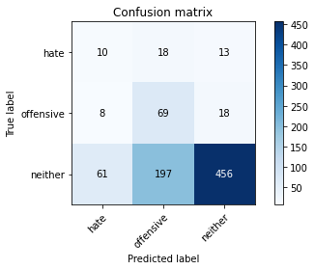

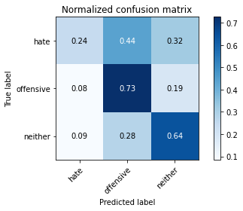

precision recall f1-score support

hate 0.13 0.24 0.17 41

offensive 0.24 0.73 0.36 95

neither 0.94 0.64 0.76 714

accuracy 0.63 850

macro avg 0.44 0.54 0.43 850

weighted avg 0.82 0.63 0.69 850

average eval_loss: 1.3953056360140097, accuracy: 0.6294117647058823

training 11 epoch...

5.625500917434692 seconds used......

11 training finished! average train loss: 0.006588880558006672

evaluating...

Confusion matrix, without normalization

[[ 16 14 11]

[ 11 65 19]

[ 91 170 453]]

Normalized confusion matrix

[[0.3902439 0.34146341 0.26829268]

[0.11578947 0.68421053 0.2 ]

[0.12745098 0.23809524 0.63445378]]

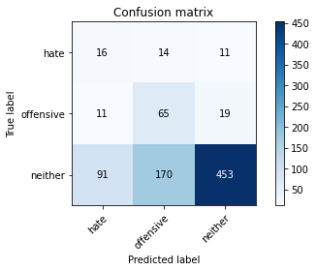

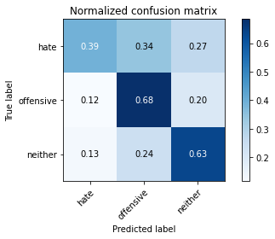

precision recall f1-score support

hate 0.14 0.39 0.20 41

offensive 0.26 0.68 0.38 95

neither 0.94 0.63 0.76 714

accuracy 0.63 850

macro avg 0.44 0.57 0.45 850

weighted avg 0.82 0.63 0.69 850

average eval_loss: 1.4392702698620945, accuracy: 0.6282352941176471

training 12 epoch...

5.65756630897522 seconds used......

12 training finished! average train loss: 0.005210237338259403

evaluating...

Confusion matrix, without normalization

[[ 14 13 14]

[ 9 65 21]

[ 84 166 464]]

Normalized confusion matrix

[[0.34146341 0.31707317 0.34146341]

[0.09473684 0.68421053 0.22105263]

[0.11764706 0.232493 0.64985994]]

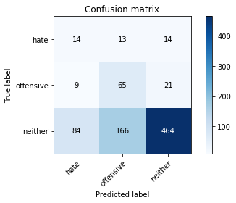

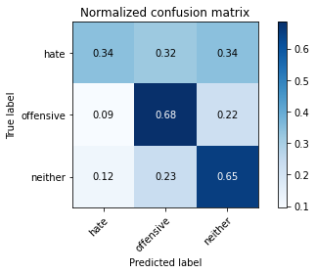

precision recall f1-score support

hate 0.13 0.34 0.19 41

offensive 0.27 0.68 0.38 95

neither 0.93 0.65 0.77 714

accuracy 0.64 850

macro avg 0.44 0.56 0.45 850

weighted avg 0.82 0.64 0.69 850

average eval_loss: 1.3946187226751516, accuracy: 0.6388235294117647

training 13 epoch...

5.6199049949646 seconds used......

13 training finished! average train loss: 0.003414147638573518

evaluating...

Confusion matrix, without normalization

[[ 10 18 13]

[ 8 69 18]

[ 66 185 463]]

Normalized confusion matrix

[[0.24390244 0.43902439 0.31707317]

[0.08421053 0.72631579 0.18947368]

[0.09243697 0.25910364 0.64845938]]

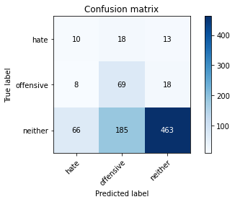

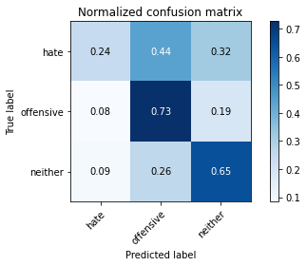

precision recall f1-score support

hate 0.12 0.24 0.16 41

offensive 0.25 0.73 0.38 95

neither 0.94 0.65 0.77 714

accuracy 0.64 850

macro avg 0.44 0.54 0.43 850

weighted avg 0.82 0.64 0.69 850

average eval_loss: 1.4833524668112743, accuracy: 0.6376470588235295

training 14 epoch...

5.606992721557617 seconds used......

14 training finished! average train loss: 0.002387733318351416

evaluating...

Confusion matrix, without normalization

[[ 10 16 15]

[ 9 63 23]

[ 71 166 477]]

Normalized confusion matrix

[[0.24390244 0.3902439 0.36585366]

[0.09473684 0.66315789 0.24210526]

[0.09943978 0.232493 0.66806723]]

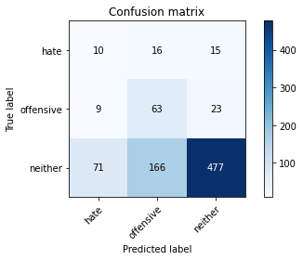

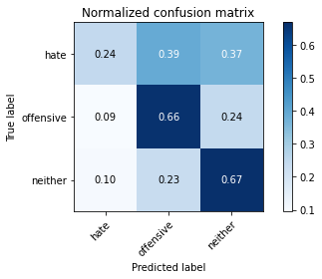

precision recall f1-score support

hate 0.11 0.24 0.15 41

offensive 0.26 0.66 0.37 95

neither 0.93 0.67 0.78 714

accuracy 0.65 850

macro avg 0.43 0.53 0.43 850

weighted avg 0.81 0.65 0.70 850

average eval_loss: 1.4165939440257673, accuracy: 0.6470588235294118

training 15 epoch...

5.582683324813843 seconds used......

15 training finished! average train loss: 0.0023126016151056522

evaluating...

Confusion matrix, without normalization

[[ 9 18 14]

[ 7 71 17]

[ 58 202 454]]

Normalized confusion matrix

[[0.2195122 0.43902439 0.34146341]

[0.07368421 0.74736842 0.17894737]

[0.08123249 0.28291317 0.63585434]]

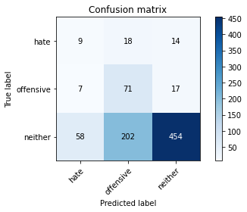

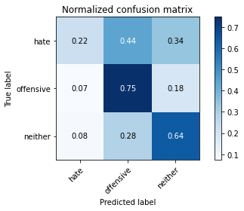

precision recall f1-score support

hate 0.12 0.22 0.16 41

offensive 0.24 0.75 0.37 95

neither 0.94 0.64 0.76 714

accuracy 0.63 850

macro avg 0.43 0.53 0.43 850

weighted avg 0.82 0.63 0.68 850

average eval_loss: 1.6182151266352036, accuracy: 0.6282352941176471

training 16 epoch...

5.622219800949097 seconds used......

16 training finished! average train loss: 0.0022550178998951903

evaluating...

Confusion matrix, without normalization

[[ 8 19 14]

[ 7 70 18]

[ 60 192 462]]

Normalized confusion matrix

[[0.19512195 0.46341463 0.34146341]

[0.07368421 0.73684211 0.18947368]

[0.08403361 0.26890756 0.64705882]]

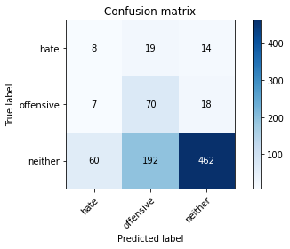

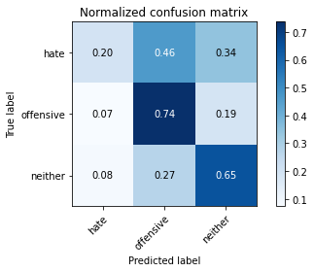

precision recall f1-score support

hate 0.11 0.20 0.14 41

offensive 0.25 0.74 0.37 95

neither 0.94 0.65 0.76 714

accuracy 0.64 850

macro avg 0.43 0.53 0.43 850

weighted avg 0.82 0.64 0.69 850

average eval_loss: 1.6098340440888044, accuracy: 0.6352941176470588

training 17 epoch...

5.55047607421875 seconds used......

17 training finished! average train loss: 0.001742985953266422

evaluating...

Confusion matrix, without normalization

[[ 9 16 16]

[ 8 58 29]

[ 53 158 503]]

Normalized confusion matrix

[[0.2195122 0.3902439 0.3902439 ]

[0.08421053 0.61052632 0.30526316]

[0.07422969 0.22128852 0.70448179]]

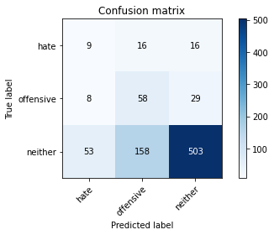

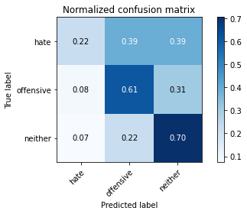

precision recall f1-score support

hate 0.13 0.22 0.16 41

offensive 0.25 0.61 0.35 95

neither 0.92 0.70 0.80 714

accuracy 0.67 850

macro avg 0.43 0.51 0.44 850

weighted avg 0.81 0.67 0.72 850

average eval_loss: 1.4246420894402925, accuracy: 0.6705882352941176

training 18 epoch...

5.555582284927368 seconds used......

18 training finished! average train loss: 0.0014889784668210065

evaluating...

Confusion matrix, without normalization

[[ 9 18 14]

[ 8 65 22]

[ 61 196 457]]

Normalized confusion matrix

[[0.2195122 0.43902439 0.34146341]

[0.08421053 0.68421053 0.23157895]

[0.08543417 0.2745098 0.64005602]]

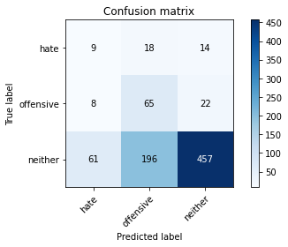

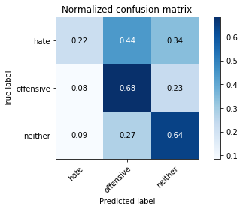

precision recall f1-score support

hate 0.12 0.22 0.15 41

offensive 0.23 0.68 0.35 95

neither 0.93 0.64 0.76 714

accuracy 0.62 850

macro avg 0.43 0.51 0.42 850

weighted avg 0.81 0.62 0.68 850

average eval_loss: 1.6813568390992493, accuracy: 0.6247058823529412

training 19 epoch...

5.603618383407593 seconds used......

19 training finished! average train loss: 0.0011959259702254916

evaluating...

Confusion matrix, without normalization

[[ 10 17 14]

[ 8 64 23]

[ 67 188 459]]

Normalized confusion matrix

[[0.24390244 0.41463415 0.34146341]

[0.08421053 0.67368421 0.24210526]

[0.09383754 0.26330532 0.64285714]]

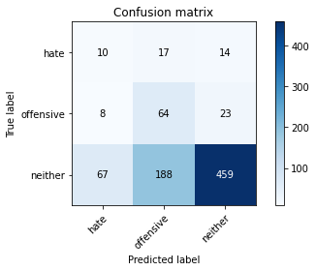

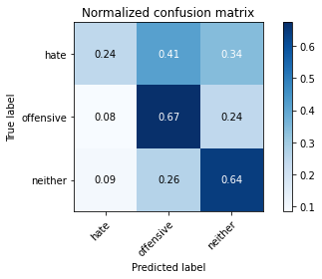

precision recall f1-score support

hate 0.12 0.24 0.16 41

offensive 0.24 0.67 0.35 95

neither 0.93 0.64 0.76 714

accuracy 0.63 850

macro avg 0.43 0.52 0.42 850

weighted avg 0.81 0.63 0.68 850

average eval_loss: 1.671417012052654, accuracy: 0.6270588235294118

training 20 epoch...

5.613130569458008 seconds used......

20 training finished! average train loss: 0.0012806382623643407

evaluating...

Confusion matrix, without normalization

[[ 9 18 14]

[ 8 64 23]

[ 59 191 464]]

Normalized confusion matrix

[[0.2195122 0.43902439 0.34146341]

[0.08421053 0.67368421 0.24210526]

[0.08263305 0.267507 0.64985994]]

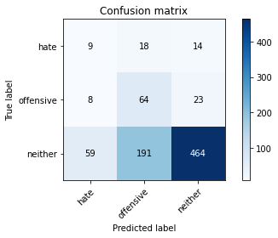

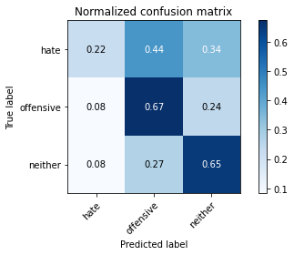

precision recall f1-score support

hate 0.12 0.22 0.15 41

offensive 0.23 0.67 0.35 95

neither 0.93 0.65 0.76 714

accuracy 0.63 850

macro avg 0.43 0.51 0.42 850

weighted avg 0.81 0.63 0.69 850

average eval_loss: 1.6775294488165962, accuracy: 0.6317647058823529